CAP GEMINI Ernst & young’s

Overall report oct 2001 – oct 2002

Online availabilityof public services:

How does europe progress?

web based survey on electronic

public services

Prepared by:
Cap Gemini Ernst & Young
January 2003

For:
European Commission
DG Information Society
TABLE OF CONTENTS

1 INTRODUCTION 1
2 The EC’s Benchmark Study: Electronic Public Services in Europe 2
2.1 The scope of the survey within the eEurope programme of the European Commission 2
2.2 The survey framework 3
2.2.1 Participating countries 3
2.2.2 Twenty basic public services 3
2.2.3 The Scoring Framework: 4 Stages of Online Development and Beyond 4
2.2.4 Delimitations 5
2.3 Methodology: CGE&Y’s Web-based Survey 6
2.3.1 Module 1: Screening the governmental structure of the participating countries and listing the service providers 6
2.3.2 Module 2: Sampling of multiple service providers 7
2.3.3 Module 3: URL identification 8
2.3.4 Module 4: Web-based survey and scoring of the websites 8
3 Results: How does Europe Progress? 10
3.1 Overall progress 10
3.2 Target group: Citizens versus businesses 11
3.3 The four service clusters 13
3.3.1 Income generating services 14
3.3.2 Registration 15
3.3.3 Returns 16
3.3.4 Permits & Licenses 17
3.4 Results by country 18
4 Analysis of the progress 21
4.1 Coordinated service provision, simple procedure 22
4.2 Dispersed service provision, simple procedures 22
4.3 Coordinated service provision, complex procedure 23
4.4 Dispersed service provision, complex procedures 24
5 Enablers for further eGovernment development 25
5.1 Leadership 26
5.1.1 Vision 26
5.1.2 Commitment 26
5.1.3 Policy 26
5.2 Organisation 26
5.2.1 Process 26
5.2.2 Management 26
5.2.3 Skills 27
5.3 Culture 27
5.3.1 Customer orientation 27
5.3.2 Communication 28
5.3.3 Partnership 28
5.4 Technology 28
5.4.1 Security 28
5.4.2 Connectivity 29
5.4.3 Infrastructure 29
6 A Best Practice for Every Service 30
6.1 Income Taxes 30
6.2 Job Search Services 31
6.3 Social Security Benefits 32
6.4 Personal Documents 33
6.5 Car Registration 34
6.6 Application for Building Permission 35
6.7 Declaration to the Police 36
6.8 Public Libraries 37
6.9 Birth and Marriage Certificates 38
6.10 Enrolment in Higher Education 39
6.11 Announcement of Moving 40
6.12 Health Related Services 41
6.13 Social Contribution for Employees 42
6.14 Corporate Tax 43
6.15 VAT 44
6.16 Registration of a New Company 45
6.17 Submission of Data to the Statistical Office 46
6.18 Custom Declaration 47
6.19 Environment-related permits 48
6.20 Public Procurement 49
7 Conclusions 50
8 Annex 1. The analysed service providers and the percentage of online presence 51
9 Annex 2: The Service Classification 52
10 Annex 3: eGovernment Policies in Europe 53

DISCLAIMER:
The views expressed in this publication are those of the authors and do not necessarily reflect the official European Commission's view on the subject. This report or parts of it may be reproduced, copied or quoted under the condition that such reproduction, copy or qoute expressly refers to its source.

© Cap Gemini Ernst & Young 2003

INTRODUCTION
This document comprises the overall reporting of the first three measurements of online development of public services in Europe. The report presents the progress Europe made with respect to the online sophistication of their public service providers’ Web sites and offers a high level view on the most important enablers of eGovernment.

In chapter 2, the benchmark study conducted by Cap Gemini Ernst & Young (CGE&Y) is situated in the broader context of the European Commission’s eEurope programme. Next to the context, also the survey framework and the methodology of the benchmark study are detailed.

The global results of online sophistication of public service providers in Europe and the progress realised since the first measurement in October 2001, are presented in chapter 3. The results are considered from the following perspectives:

The target groups citizens and businesses
The service clusters income-generating, registration, returns and permits & licences
The different European countries participating in the study.

An analysis of the results, conducted on the basis of the analysis framework, is presented in chapter 4.

Subsequently in chapter 5 a number of enablers for a future eGovernment implementations are analysed and listed.

In Chapter 6 a best practice of an online application for each of the analysed public services within the participating countries is presented and analysed.
Finally, the conclusions are listed in chapter 6.

The EC’s Benchmark Study: Electronic Public Services in Europe

The scope of the survey within the eEurope programme of the European Commission
This survey conducted by CGE&Y on demand of the European Commission is part of the benchmarking programme that assesses the progress of eEurope. The eEurope initiative was launched by the eEurope 2002 Action Plan endorsed by the Feira European Council in June 2000 and has been strengthened by the issue of the eEurope 2005 Action Plan in June 2002.

The objective of this Action Plan is to provide a favorable environment for private investment and for the creation of new jobs, to boost productivity, to modernize public services, and to give everyone the opportunity to participate in the global information society.

The Barcelona European Council in March 2002 called on the Commission to draw up an eEurope action plan focusing on “the widespread availability and use of broadband networks throughout the Union by 2005 and the development of the Internet protocol IPv6… and the security of networks and information, eGovernment, eLearning, eHealth and eBusiness”

eEurope is about bringing the benefits of the information society to all Europeans. The benchmark programme is about monitoring the progress and enabling the European Commission to take informed decisions for the future.

eEurope benchmarking is based on a list of 23 key indicators agreed in November 2000. These indicators are covering different domains:
- Internet Users and Usage
- Internet access costs
- E-learning
- A secure information structure
- E-government
- E-health
The Web-based Survey on electronic Public Services on the “percentage of basic public service available online” covers one of the two indicators assessing the progress Europe makes concerning the implementation of e-government. A second e-government indicator is covering the percentage of Internet users visiting e-government sites. (Further in this study the correlation between both indicators is analysed).

The indicator analysed in the CGE&Y study focuses on the supply site of the e-government approach: it is focusing on the online front-end public service provision. It measured the availability of the public services on the Internet and the level of online sophistication of the delivery process. The objective of the benchmark is to enable participating countries to analyse progress in the field of eGovernment and to compare performance.

Until now this study has been conducted on a bi-annual basis: October 2001, April 2001 and October 2002. The current report describes the progress that has been measured between the first survey in October 2001 and the third in October 2002.

The survey framework

Participating countries
The survey initially covered 17 countries: the 15 member states of the EU, Norway and Iceland. Switzerland also joined from the second measurement. The country codes used in this report are presented in Table 1.

A | Austria
B | Belgium
DK | Denmark
FIN | Finland
F | France
D | Germany
EL | Greece
ISL | Iceland
IRL | Ireland
I | Italy
L | Luxembourg
NL | Netherlands
NOR | Norway
P | Portugal
E | Spain
CH | Switzerland
S | Sweden
UK | United Kingdom
Table 1: Country Codes

Twenty basic public services
The European Commission defined a common list of twenty basic public services for which the online sophistication had to be benchmarked. Twelve of these services are aimed at individual citizens (G2C, Government to Citizens), eight others are aimed at business (G2B, Government to Businesses). The 20 services are presented in Table 2.

Citizens | Businesses
Income Taxes | Social Contribution for Employees
Job Search | Corporate Tax
Social Security Benefits | VAT
Personal Documents | Registration of a New Company
Car Registration | Submission of Data to the Statistical Office
Application for Building Permission | Custom Declaration
Declaration to the Police | Environment-related Permits
Public Libraries | Public Procurement
Birth and Marriage Certificates
Enrolment in Higher Education
Announcement of Moving
Health-related Services
Table 2: Public Services

The Scoring Framework: 4 Stages of Online Development and Beyond
In order to measure the level of online availability of the basic public services, the European Commission worked out a four-stage framework:
- Stage 1 - Information
- Stage 2 - One-way Interaction
- Stage 3 - Two-way Interaction
- Stage 4 - Full electronic case handling.

The CGE&Y team clarified the definitions of the four stages in order to ensure the accuracy of the benchmark study and a correct interpretation of the results:
- Stage 1- Information: The information necessary to start the procedure to obtain this public service is available online.
- Stage 2 - One-way Interaction: The publicly accessible website offers the possibility to obtain in a non-electronic way (by downloading forms) the paper forms to start the procedure to obtain this service. An electronic form to order a non-electronic form is also considered as stage 2.
- Stage 3- Two-way Interaction: The publicly accessible website offers the possibility of an electronic intake with an official electronic form to start the procedure to obtain this service. This implies that there must be a form of authentication of the person (physical or juridical) requesting the services in order to reach stage 3.
- Stage 4- Full electronic case handling: The publicly accessible website offers the possibility to completely treat the public service via the website including decision and delivery. No other formal procedure is necessary for the applicant via "paperwork".

Besides these 4 stages a stage 0 was introduced to capture two possible research outcomes:
- Total absence of any publicly accessible website managed by the service provider
- The public service provider has a publicly accessible website, but this one does not offer any relevant information, interaction, two-way interaction or transaction possibilities at all concerning the analysed service.

The figure below demonstrates the scoring framework used for this benchmark exercise.

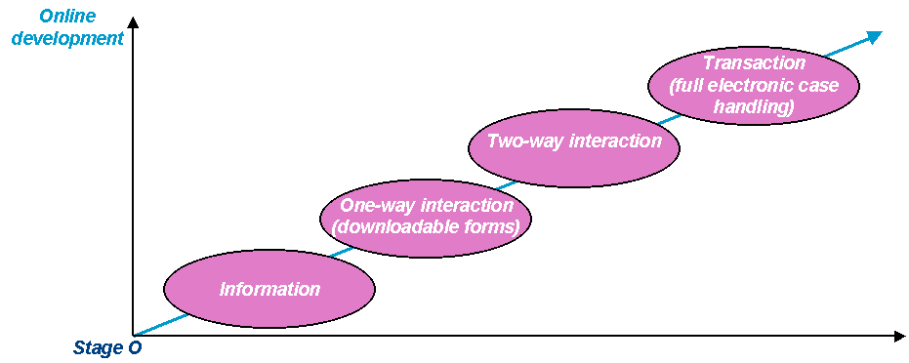
Figure 1: The Scoring Framework
The online availability of public services will thus be determined by the extent to which it is possible to provide the service electronically, or in other words to what extend the service provision is online sophisticated.
The scoring framework presented above comprises the general framework. For each public service included in the survey the scoring framework has been re-fined.

Delimitations
The fact that this study relies on a well-defined framework also implies some restrictions:
- This survey evaluates the online accessibility of public services for citizens and businesses on the Internet. This means that eGovernment initiatives, using any other electronic means to reach their target groups, are not taken into account.
- The framework of this study implies a clear front office approach, only taking into account the public service offering online. It does not evaluate the re-designing of back-office procedures eGovernment often implies, neither the use of these services by citizens or businesses.
- The study does not evaluate the quality of the information provided, neither of the delivery process.
- The measurement is a snapshot: it provides a picture at a certain moment, while the situation is evolving continuously. For example website-applications of service providers that in the period of the measurement are for a longer period suspended are considered as not available online (stage 0).
- Full automated service provision systems, e.g. in several countries citizens do not have to apply for child allowances as they are delivered automatically, can be considered as beyond stage 4. The survey framework does not allow honoring these high-level eGovernment solutions as they are considered as not relevant given the scope of the survey.

Methodology: CGE&Y’s Web-based Survey
The survey-process developed by the CGE&Y-team contains 4 modules:
- Screening the governmental structure of the participating countries
- Sampling of the multiple service providers
- Identification of URL’s
- Web-based survey and scoring of the websites
The process chart below demonstrates the different phases:

Figure 2: Survey Process
In the next paragraphs the different modules will be further described.

Module 1: Screening the governmental structure of the participating countries and listing the service providers
The CGE&Y-team opted for a bottom-up approach in elaborating the research methodology. The formulated start question to be answered was, from the point of view of an applicant (individual citizen or business): “what is the responsible service provider for the delivery of a particular public service in a specific country?” The websites of these service providers where then defined as the observation units of the research.

In a first phase of the research a network of government experts in each of the 18 countries was consulted to obtain an overview of the different ways in which the 20 public services are organised and of the variety of Internet applications being developed in Europe.
This governmental screening of each country was a combined effort of the Brussels co-ordination team and the local governmental experts of CGE&Y in the 18 countries. This screening provided a complete overview of the organisation of the service providers to be evaluated. The political landscaping was updated for the second and third measurement.
The different categories of service providers taken into account are:

- National governmental units
- Regional governmental units
- Cities and municipalities
- Specific multiple service providers:
- Public libraries
- Hospitals
- Universities / institutes of higher education
- Police offices.

Module 2: Sampling of multiple service providers
As a fully exhaustive survey of the complete lists of all the multiple service providers was not feasible, CGE&Y elaborated a statistical methodology to draw a representative sample if the number of units was too large. This methodology combines different statistical methods, depending on the size and character of the service providers:
- Stratification
- Systematic sampling with unequal probability
- Random sampling
A combination of stratification and systematic sampling was used for these service providers organized on a specific regional base:
- Municipalities
- Regional authorities
- Local police offices
- Libraries
The weighing methodology that was elaborated for the systematic sampling also allows the calculation of a scientifically valid aggregate score for the individual websites of multiple service providers.

The sampling procedure was repeated for each measurement: the overall scores of public services provided by multiple service providers were based on new samples.

Module 3: URL identification
The next step in the set-up of the web-survey was the identification of the URL's of the multiple service providers. To be able to give a maximum guarantee that service providers which were selected to participate in the research and that manage an official website also effectively participated, CGE&Y developed a search strategy that offered a maximum guarantee that the website is found.
A first outcome of this study is then the percentage of service providers online:

From the 10.569 public service providers taken into account for the third measurement, 9119 had a publicly accessible website. This implies that a total of 86% of service providers are present online, an increase of 12% compared to the first measurement.

In Annex 1. The analysed service providers and the percentage of online presence - a table gives an overview of the number of analysed service providers per public service in each country and of the percentage of online presence.

Module 4: Web-based survey and scoring of the websites
The URL’s of the service providers were introduced in a relational database. This database feeds a web-based scoring tool developed by CGE&Y to carry out web-surveys.

The research team to execute the content analysis and scoring of the URL’s uses this web-enabled application. As the number of URL’s to score per country is extensive and the exact interpretation of the different stages is crucial, the tool contains a very precise and structured procedure. The scoring tool guides the researcher through a well-defined path that leads to a score per service.

Checks and controls are built in and performed at various stages in this research tool. This function of checks and controls guarantees a maximum level of accuracy in the results.

The scoring tool recalculates the scoring of the individual websites as percentage of the maximum score per public service.

The average score of a service in a country is recalculated to an overall percentage of online sophistication:
- Stage 0 = score 0 - 0,99 = 0% - 24%
- Stage 1 = score 1 -1,99 = 25% - 49%
- Stage 2 = score 2 - 2,99 = 50% - 74% or stage 2
- Stage 3 = score 3 – 3,99 = 75% - 99% or stage 3
- Stage 4 = score 4 = 100% or stage 4

For certain services the maximum stage was limited to Stage 3: personal documents, declaration to the police, certificates (birth and marriage), announcement of moving and submission of data to statistical offices.

The calculation of the percentages is then as follows:
- Stage 0 = score 0 - 0,99 = 0% - 32%
- Stage 1 = score 1 -1,99 = 33% - 66%
- Stage 2 = score 2 - 2,99 = 67% - 99%
- Stage 3 = score 3 = 100%
The final percentage per country is calculated as the average of the percentages of the 20 services for that country. The percentage per country for public services for citizens is the average of the percentage of the services 1 to 11. The percentage per country for public services for business is the average of the percentage of the services 12 to 20.

Some of the public service providers are classified as “not relevant” for certain countries due to the legal context and administrative organization of that specific country. The overall score of that country is then calculated as the average of the relevant services.

Results: How does Europe Progress?
The improvement of Europe with respect to the online sophistication of public service provision will be measured by comparing the results of the third eGovernment measurement in October 2002 with those of the first measurement in October 2001. In other words we will analyse how much the surveyed European countries evolved over one year with respect to the online sophistication of public services. All growth figures will be expressed in %-point which implies that the absolute growth figures are presented.
An important remark is that, unless mentioned otherwise, the results of Switzerland are not taken into account when analysing the progress since the country was not yet included in the first measurement.

Overall progress
The third measurement resulted in an overall average score of 60% for the 20 public services in the 17 countries when Switzerland is excluded. This means a considerable increase of 15%-points compared to the first measurement in October 2001. On average the web-enabling of public services in Europe reaches a level somewhere between one-way interaction (downloadable forms) and two-way interaction (electronic forms) while in the first measurement one year ago only the level somewhere between information and one-way interaction was attained. This means that eGovernment in Europe was in 2001 already developed beyond the phase providing information and that in 2002 the interactivity with the users was strengthened.

Figure 3: Overall Survey Results
Despite the significant growth between the third and the first measurement it is important to remark that growth slowed down during the second six month period. The major growth in other words was realised in the first six months (10%-point growth in the first half year compared to 5%-point growth in the second half year).
In the next paragraphs the overall average will be analysed in more detail from three perspectives:
- By target group to whom the service is offered: citizens versus businesses
- By the nature of the service: The 20 surveyed services are grouped into 4 clusters of related services, namely income generating, registration, permits & licenses and returns.
- By country: here the different countries are analysed towards the level of online sophistication.
An overview of the results and progress per service has been included in

Target group: Citizens versus businesses
As we can see in the graph below the level of online sophistication of public services has grown for both Government to Citizen as Government to Business services.
For public services to citizens the third measurement registered an average of 52%, which can be translated in a growth of 12%-points compared to the first measurement (40%). For the public services directed to businesses an average of 72% could be found which indicates a substantial growth of 19%-points compared to the result of the first measurement (53%).

Figure 4: Target group: Citizens versus businesses

Overall it can be said that in the results of the first measurement the public services for businesses scored significantly higher than the public services for citizens and that this difference increased even substantially over the observation period (from a difference of 13%-points to a difference of 20%-points).

A hypothesis that can be formulated to explain the higher level of online sophistication and the more important growth of the Government to Business services is that national governments choose as a political priority to enhance the climate for investors by organizing high level eGovernment solutions for companies. An objective element explaining the difference between the results of public services for both client groups is the fact that public services for business are in general organized in a more centralized way. Thus the introduction of interactive full electronic service delivery for businesses requires less complex decision processes and can evolve faster than the introduction of eGovernment service delivery for citizens, organized more dispersed on a local basis.

Nevertheless both categories of public services moved one level of online sophistication upwards since the first measurement.

Public services for citizens moved from the information stage to the level of one-way interaction (downloadable forms) while the public services for businesses almost reached the level of two-way communication (= electronic forms). This is visualized in the graph below.

Figure 5: Progress by Target Group

Moreover the same trend is also observed on a country level: in almost every country included in the survey the public services for businesses score significantly higher than the public services for citizens and additionally they also grew faster over time than the public services for citizens. This analysis is further elaborated in paragraph 3.4 “Results by country”.

The four service clusters
In order to identify common trends within groups of related services, the 20 analyzed public services have been clustered in four types of services:

- Income-generating services: Financial flows from citizens and businesses to the government:
  - Income taxes
  - Corporate taxes
  - VAT
  - Social contribution for employees
  - Customs declaration)

- Registration: Services related to recording object- or person-related data in official registers with respect to administrative obligations:
  - Birth and marriage certificates
  - Registration of a new company
  - Car registration
  - Announcement of moving
  - Submission of data to statistical offices

- Returns: Public services given to citizens and businesses in return for taxes and contributions:
  - Social security benefits
  - Public libraries
  - Public procurement
  - Job search services
  - Declaration to the police
  - Health related services

- Permits & Licenses: Documents delivered by governmental bodies, which allow you to drive, to travel, to build a house, etc.:
  - Personal documents
  - Application for building permission
  - Enrolment in higher education
  - Environment related permits

The graph below visualises the results and the evolution of the aggregated scores of each of the service clusters. The next paragraph provides an in depth analysis of the evolution for each specific cluster.

Figure 6: Evolution by Cluster

Income generating services
With an average cluster score of 82% the income-generating cluster is the cluster with the highest measured online sophistication. In this cluster every service scores higher than the global survey average of 60%. The average growth rate of this cluster is 20%-point which is also the most important growth of all four clusters. The reason behind this fast growth is two-fold : the hypothesis that national governments make political priority introducing full electronic solutions to collect taxes, and the fact that the tax collection is in most countries organized in a centralized way, enabling a faster implementation of eGovernment solutions.

Figure 7 Income-generating Services
The left graph of Figure 7 points out to what extent each of the analyzed countries progressed for the public services taken into account in this cluster. Five countries (Denmark, France, Italy, Sweden and Finland) reached the maximum score of 100% for each of the 5 income-generating services. This implies that they reached the maximum level of online sophistication, namely full transactional case handling, for all of these services. The countries that made the highest progress in 12 months are Sweden (60%-points), Ireland (45%-points) and Belgium (40%-points).

In the second graph, the average evolution and the growth of each of the public services included in the cluster is shown. The average score of the income-generating cluster follows the same trend as the overall survey average meaning that despite the significant growth of 20% between the first and the third measurement, growth slowed down during the second half of the year. Also on the individual service level we observe the same pattern. The only exception here is the service “customs declaration” that generated a growth acceleration in the second half of the year. Despite this growth, “customs declaration” still lags behind on the other services which have all reached the online sophistication level of two-way communication.

Suprisingly, the initially lowest scoring service, namely “social contribution for employees”, generated the highest growth rate of 35%-point which resulted in a score of 85% for the third measurement. This finding is in line with the finding that services for business are growing faster than services for citizens. In several countries important back-office reorganisations made it possible to introduce single entry points via governmental portal sites where businesses can easily introduce data concerning their employees.

Registration
With a cluster average of 58%, the cluster of registration services scores slightly below the total average of 60%. The average growth of this cluster between the first and the third measurement is 15% which equals the overall survey growth rate.

Figure 8: Registration Services
On country level only Sweden obtained the maximum score of 100% for all registration services. Only three countries, Sweden, Denmark and Finland reached a sophistication level of two-way interaction or higher while most other countries score around 50% which corresponds to the online sophistication level of one-way interaction.

The second graph of Figure 8 demonstrates that the best scoring and fastest growing service of the registration cluster is the “Submission of data to statistical office” with a score for the third measurement of 79% and a growth rate of 23%-point. The obvious explanation here is that the centralized organization of the statistical offices in the different countries enables the progress of online sophistication.

On average the registration cluster growth has slowed down during the second half year. Exceptions on this trend are the services “Birth and marriage certificates” and “Car registration”, were growth accelerated slightly during the second half of the year. Despite their growth acceleration they are still the lowest performing registration services, not reaching the online sophistication level of one-way interaction. But as for the income-generating cluster it can be noticed that the initially lowest scoring service (Birth and marriage certificate) generates a substantial growth rate between the first and the third measurement.

Returns
The overall cluster average for the “returns” cluster is 53% which is below the overall survey average of 60%. Also the growth rate of 13%-point over the last year ends below the overall survey growth rate of 15%-point. The assumption can be made that European governments have given less priority to enhancing the online sophistication of these services available for citizens and businesses in counterpart of their tax contribution.
Figure 9: Returns Services
Looking at Figure 9 it can be noticed that the average score reflects two extreme values and that four services are scoring close to 50% which corresponds with the one-way interaction online sophistication level.

The high-scoring service in the cluster is “job search services” with a score of 90%. In addition this service is also the best performing service of the overall survey. 13 of the 17 surveyed countries reached the maximum score of 100% on “job search services” meaning that a full e-enabled case handling is possible. Public authorities seem to draw particular importance to enhance the online sophistication of jobsites where supply and demand of employers and jobseekers can meet. This is certainly in line with the European political priority concerning the improvement of the employability in the Member states of the European Union.

The low-scoring service within the cluster is health-related services with a score during the third measurement of 14%. The explanation here is that the research definition of the service – the standard procedure to obtain an appointment at a hospital – seems less relevant as indicator for the development of eGovenrment in this sector.

The highest growth rate is achieved by the “Public libraries” with a growth rate of 20%-points between the first and the third measurement.

Similar to the previous two clusters also this cluster follows the same trend of a declining growth during the second half of the year except “Job search services” where growth even accelerated during the second half. This means that within this cluster the higher growth rates are not realized by initially lower performing services but by the initially highest scoring service.

The best performing countries in this cluster are Denmark (95%), Sweden (85%) and Ireland (83%) that score significant above the cluster average of 53%. The scores of all other countries fluctuate close around 50% corresponding to the one-way interaction sophistication level.

Permits & Licenses
This cluster is the lowest performing cluster with a cluster average of 44%. It is the only cluster that could not yet reach on average the online sophistication level of one-way interaction (50%). Also the average growth of this cluster, namely 11%-point, is rather low compared to the other clusters. The four services taken into account in this service are each organized on a decentralized way and the delivery process is rather complex. The effort needed to enhance their online availability is therefore more important and less effective.
Figure 10: Permits and Licences
Compared to other surveyed services, the growth rates of the services in the permits & licenses cluster are rather low. The highest growth rates within the cluster are realized by “Enrollment in higher education” (17%) and “Environment-related permits” (16%). The cluster also includes the two slowest growing services of the survey namely “Personal documents” and “Application for building permits” with a respective growth of 5%-point and 6%-point.

On a country level, Ireland is a remarkable exception in the cluster with a score of more than twice the cluster average (92%). The centrally organized administration of Ireland combined with the important efforts of the government to develop and implement electronic government solutions explain these exceptional results.

Countries that made good progress between the first and the third measurement include the UK, Denmark, Finland, Sweden and Luxembourg with growth rates of 10%-point and higher.

Results by country
Figure 11 represents the scores of the first and the third measurement and the respective growth (in %-point) for each country.

As we can see all countries have a positive growth rate varying from 3%-point for Norway, up to 26%-point for Sweden.

The countries that made the most progress in the survey are Sweden (26%-point), Belgium (24%-point) and Denmark (23%-point). Due to their high growth rate Sweden was able to take over the leading position of online sophistication of public services from Ireland and Belgium was able to double its score compared to the first measurement.

All countries except Belgium, Germany and Luxembourg have attained a score above 50% meaning that they have on average at minimum reached the level of online sophistication of one-way interaction. Four countries reached already on average the two-way interaction level corresponding to a score above 75% (Sweden, Ireland, Denmark and Finland). In the first measurement 8 countries were still scoring below 50% and zero countries achieved to score 75% or higher.

Figure 11: Results and Progress by Country
Figure 12 shows that except for Germany, Norway, Portugal and the UK, all surveyed countries gained on average one level of online sophistication. The majority of the countries are now on average situated in the one-way interaction stage of online sophistication. While in the first measurement there were still 2 countries with no form of online sophistication (Belgium and Luxembourg), in the third measurement all countries have a form of online availability of public services resulting in a country score of at least 25%.

Figure 12: Progress by Country
Although none of the countries reached the stage of full electronic case handling for all their relevant surveyed public services, some countries achieved the maximum score of 100% for more than 50% of their services. The maximum score of 100% was received by Sweden for 66,67% of the relevant surveyed services (12 out of 18), by Denmark for 61,11% of the relevant surveyed services (11 out of 18) and by Ireland and Finland for 50% of the relevant surveyed services (9 out of 18). These 4 countries also take the first 4 places in the overall survey ranking.

A breakdown of the country-results by target group confirms the overall finding: in almost every country included in the survey the public services for businesses score significantly higher than the public services for citizens and additionally they also grew faster over time than the public services for citizens. However for some countries the growth in online sophistication of public services for businesses is lower than the growth in online sophistication of public services for citizens.
One of the possible explanations can be that for countries like Ireland, Finland and Portugal the score for public services for businesses was already relatively high during the first measurement compared to the other countries and therefore less possibilities for further growth remained.

Figure 13: Results and Growth by Target Group

Analysis of the progress
An analysis framework was created based on the observation that the best results were achieved by centrally co-ordinated public services that have limited complex procedures (such as job search, VAT and income taxes) and that the services with the lowest scores are typically co-ordinated by local service providers and have more complex procedures (such as application for building permission and environment related permits).

The framework is not only used to analyse the position of each service in the benchmarking exercise of online sophistication, it also serves as an explanation-framework on how public service providers can progress to a higher level of eGovernment sophistication.

Within this framework, two main enablers can be distinguished for making progress:
- Co-ordinated eGovernment solutions or making the delivery process more centralised
- Extensive back-office reorganisations or simplifying the procedure to obtain the service
The analysis framework is illustrated in Figure 14. On the x-axis the typical organisation of the service provider is presented: ranging from “co-ordinated at one centrally” to “dispersed at different delivery points”. On the y-axis the complexity of the procedure behind the public service is presented.

Although in this study the organisation of the back-office was not measured the political landscaping of the governmental organisation in the different countries provided an indication on the complexity of the back-office of service providers in the participating countries.
Figure 14 Analysis Framework

In the next paragraph the different quadrants are explained and growth paths for the enhancement of the eGovernment for services situated in each of the quadrants are suggested.

The precise positioning of each service in the analysis framework is determined by the political structure of a country with respect to the authority level (national-regional-local) by which the service is provided and on the complexity of the legal context with respect to the complexity of its underlying procedure(s).

Coordinated service provision, simple procedure

Services in this quadrant are characterised by a centralised service provision with a relative simple service provision procedure. Job search services are in almost every analysed country a typical example of this category.
Those services score on average high, as the step to obtain a high level of online sophistication via the organisation of a single access-point on the web does not require important back-office reorganisations. The online sophistication of the public Job search services evolved from 81% in October 2001 to 91% in October 2002. The growth of 10%-point scores under the average growth: most countries had already a well-organised central access-point for their job search offices. The average growth can be explained by the fact that in the last year the countries lacking behind in this domain implemented comparable eGovernment solutions for job search services.

Dispersed service provision, simple procedures

Public service providers in this quadrant are characterised by a dispersed service provision on a local basis and a rather simple provision process. Those service providers can take advantage of centralised online initiatives offering the users a single point of contact:

- Each of the regional/local service providers can build its own front office application by adhering to best practice examples of peer service providers and by taking advantage of knowledge sharing in the domain. A single access point is then created as a portal website where the “customer” is re-directed to his local provider.
- A single point of access can also be designed as a fully developed virtual counter, where the “customer” can apply for the service. In this case, the service application needs to be forwarded to the back-office system of the local service provider who will be responsible for the further treatment of the request.

Typical examples are public libraries: mostly organised on a local basis with a straight-forward service provision. The service Public Libraries scored in average 38% online sophistication in October 2001 and growth to 58% in October 2002. The growth is higher than the average growth: several countries implemented eGovernment solutions and created a single access point for their citizens to the local libraries. Both solutions were implemented:

- Central portal sites giving access to performant online application of local libraries, allowing the users to consult the catalogues and to reserve information carriers in those libraries.
- Centralised virtual libraries, with linked catalogues and the possibility to reserve and pick up information carriers in each related local library.

Coordinated service provision, complex procedure
Public service providers in this quadrant are characterised by centralised service providers, but rather complex delivery procedures. A typical example of a service in this quadrant is for most countries the declaration of a new company: a central physical point of access on the national or regional level, but a complex back-office organisation. The service scored in average 58% of online sophistication in October 2001 and growth to 68% in October 2002.

The online development of the services in this category with more complex underlying procedures is more slowly as it requires more extensive back-office reorganisation. This is rather a long-term operation but solutions are considered more profound as the back office organisation is adapted simultaneously with the front office solution.

Dispersed service provision, complex procedures

In general, services in the most difficult quadrant (complex procedure and dispersed service provision) are still far from a full interactive stage. The public service “application for building permission” is a typical example: applicants are confronted with local or regional organized administrations with complex back office organizations.
The service application for building permission scored in average 33% of online sophistication in October 2002, only a growth of 5%-point compared to October 2001.
For these services a combination of both enablers is needed to enhance their level of eGovernment sophistication. The diagram below demonstrates the need to combine the solutions explained in paragraphs 5.1.2. and 5.1.3. :

- Organisation of centralised online initiatives offering the users a single point of contact
- Back-office reorganisations (re-engineering delivery procedures and linking databases).

Enablers for further eGovernment development
This benchmarking study was based on the concept that complete interactive transaction of public service delivery is the ultimate goal for the eGovernment development at the supply side. In the meantime new concepts of a more holistic view on eGovernment were developed. eGovernment is considered as a global change programme towards a custom oriented governmental organisation. A transition of this importance needs a clear vision and leadership.
CGE&Y is a partner for a number of eGovernement projects in Europe and the lessons learned from these projects are listed in this chapter. These lessons are translated in a model with important enablers for the further development of eGovernment. These enablers are clustered into the following categories:
- Leadership
- Organisation
- Culture
- Technology
A successful eGovernment strategy should contain all elements of the model in a balanced way.

Figure 15 Enablers for further eGovernment Development

Leadership

Vision
The actual evolution of the concept of eGovernment from a technology focus towards a tool for the further development of a customer oriented governmental organization is crucial. The vision on eGovernment beyond the concept of “bringing public services online” must be integrated in most eGovernmental strategies. Governments must develop a clear vision on eGovernment as a global governmental change programme.

Commitment
Strong political commitment at all levels of government is necessary to ensure the presence of the eGovernment vision programme as a priority on the political agenda. High-level political responsibles must publicly announce their involvment towards eGovernment programmes.

Policy
The translation of the vision in a regularly updated strategic plan for the development and implementation of eGovernment on federal and regional level is a key success factor for further improvement. The eEurope plans of the European Commission triggered the Member States to elaborate and implement such national strategic plans. Annex 3: eGovernment Policies in Europe contains an overview of the most important points of these national policies, linked to their concrete realisations.

A secure funding of the rollout of eGovernment strategies is an essential element of this planning. Scattered and uncertain funding organized on an agency-by-agency basis is problematic for the realization of eGovernment.

Organisation

Process
In order to create added value of a fully automated service delivery towards the customer profound back-office re-organisation of all administrative and decision-making bodies involved in the provision of a certain service needs to be envisaged. This re-organisation not only implies an organizational revision of the procedures but also a technical integration of all related administrations involved. A lot of countries have already made huge investments in that direction, which may result in an increase of the online sophistication of public services in these countries in the near future. It is expected that these countries will move very quickly beyond stage 4.

In that model front- and back-office systems are integrated and the administration is organized towards the needs of the customer.

An important aspect of back-office re-organisation involves simplification of the underlying procedures to obtain public services which often implies legislation adjustments.

Management
The implementation of eGovernment has to be seen as an overall governmental programme organizing different eGovernment projects. An appropriate high-level programme-management is thus a key success factor for the implementation of eGovernment programmes. It contains:
- The definition of precise goals, scope, objectives and ground rules of each project
- A detailed overall work plan and underlying project plans
- Risk management defining the possible risks and planning the possible recovery actions
- Monitoring, control and project-change systems.
- Measurement of outcomes and progress.

Governments start to be aware that further eGovernment implementations also require a change process approach. eGovernment in the approach of revolutionary change of the whole functioning of the administration is one of the most important challenge modern states are actually facing. Change management techniques are necessary to lead these transformations to a success.

The implementation of the eGovernment policy needs a central agency and the building of bridges between the different bodies. Fragmented political eGovernment bodies organized on the model of the traditional administrations are slowing down further development of an eGovernment change programme.

Skills
The development of eGovernment demands a specific approach towards different customer-groups: citizens, businesses, and civil servants. The measurement and enhancement of the e-skills of each of this customer-groups is crucial. An e-capability-development plan based on a skill gap analyses for each of these stakeholders should be an integrated part of the national and regional eGovernment policies.
Specific coaching and training programmes have to be developed to overcome the gaps between the e-enablement of the user-groups and the technological possibilities. A difference in e-enablement of categories within one target group demands a tailor made approach.

Culture

Customer orientation
eGovernment involves that a cultural change must be stressed: the new eGovernment concept should be built around the central positioned customer (citizen, business or civil servant).

This implicates a government tailored toward the customers’ needs:
- Common public services are delivered automatically and customers do not longer have to introduce “demands”. (E.g. the delivery of child allowances is already organized that way in some European countries)
- Optional services are proposed to the customer. (E.g. a new passport is proposed when the old is expired)
- Permits are organized around life-events and delivered via a centralized demand. (E.g. for the construction of a house, one demand organizes all the necessary permits)
- Customers have direct access to the back office to control their files and to follow up the delivery processes
- This direct access guaranties a permanent accessibility (24x7) of all the public service providers
Data concerning citizens are as much as possible organized in linked databases and reports based on these data are submitted to the citizens and businesses for validation.

Communication
The research-team measured the correlation between the offer of e-government services and the percentage of Internet users visiting e-government sites (June 2002), a second e-government indicator. No correlation was measured, which implies that no significant link exists between the eGovernment offer and its use. This finding demonstrates that an important effort is necessary to promote and communicate about the use of eGovernment services in most countries. Marketing efforts are essential to promote the eGovernment initiatives towards the users.

Internal communication and transparency within the governmental eGovernment programmes and organisations are necessary: the development and implementation of further eGovernment services as a global government change programme is a complex ongoing process. Knowledge sharing speeds up the process and increases the efficiency. Lessons learned and best practices of each project have to be made available by different channels internally and externally.

Internal and external benchmark exercises comparing the results of one country to another or to other continents can help defining best practices.

Partnership
Not only the funding of governmental programmes but also the efficiency of the implementation will be accelerated by the introduction of models of larger partnerships. The concept of Public Private Partnership in which governments work together with private partners for the realization of programmes and projects can be an important enabler for further eGovernment development. The partners can be involved in the concept and design, the rollout and the maintenance of the programme.

Technology

Security
It is obvious that security is an important enabler for further development of electronic public services: customers will only make use of the online offer if complete security is guaranteed. The five most important requirements for secure Internet applications are: authentication, authorization, privacy guarantees, integrity and incontestability. As such, it is not only important to safeguard the content of messages that are sent over the internet, but also to make sure that the recipient of the message is the person he/she pretends to be: an impermeable link between key and identity therefore needs to be established. This link can be realized by means of a PKI or Public Key Infrastructure. A PKI enables users of a public network to secure and privately exchange data through the use of a public (digital certificate) and a private (digital signature) cryptographic key pair that is obtained and shared through a trusted authority.

An extra asset in enabling the further development of electronic public services, is obtained when the legitimacy of the digital signature within the frame of a PKI has been settled in the legislation.

Connectivity
Connectivity for eGovernment services is the availability of these services for the end-user with an acceptable performance level. This enabler expresses the extent to which the population is technically equipped in order to reach the offer of onlineonline public services. The connectivity of the population should not only take into account whether or not the citizens/businesses dispose of an internet connection but also whether they dispose of other devices, such as WAP-enabled mobile phones and interactive TV. These might be used as alternative channels to offer public services to the customer.

More and more customers of public services want to use different channels through which they can be helped, preferably 24/7. These customers are entitled to receive the same qualitative services through all channels provided by governments: the Internet through e-services, use of telephone services through call-centers, classic services over the counter, snail mail, ... and maybe in the future, services provided by governments through WAP. The use of different channels adds to the increased complexity of gearing public services to one another.

Infrastructure
The technology core is crucial for the proper functioning of e-Government. The infrastructure needed to provide the eGovernments services includes in its broadest sense: hardware, middleware & software. These not only ensure the proper functioning of e-Government services, but also cover maintenance issues, such as corrections, changes and improvements.

To efficiently use the government’s infrastructure, infrastructure strategy should include a policy focusing on a common use of existing and newly implemented infrastructure. Considering the efficient application of infrastructure, the use of internet/technology-based services provides new challenges to the hardware: the number of transactions to be processed within an acceptable time. Another issue to address is the speed in which software can be implemented (new development or customizing software) to support new services.

A Best Practice for Every Service
This paragraph provides a best practice for each of the analysed services. The best practices ware chosen ad random on the basis of a lists of high scoring applications. A more in depth context-analysis is given.

Income Taxes
The project “Integrated Management of Wealth and Income Tax” was initiated by the Spanish Tax Agency (AEAT) in 1999. The project, which is illustrated here as a best practice for the declaration of income taxes by citizens, covers the entire process of tax management (information, electronic tax return filling and payment, certifications, etc) for all types of tax payers. The project aims to help the tax payer meet his tax responsibilities, simplify procedures and facilitate earlier tax refund.

Tax declarations are filled online and tax payments can be made through online banking facilities. For filing tax return, citizens obtain a Digital Certificate from the Spanish Federal Reserve. For businesses, the AEAT’s Website offers services such as declaration of corporate tax and VAT.
This project has already won several national and international awards among others the citation as eGovernment best practice by the European Commission and the WITSA (World Information Technology and Services Alliance) award.

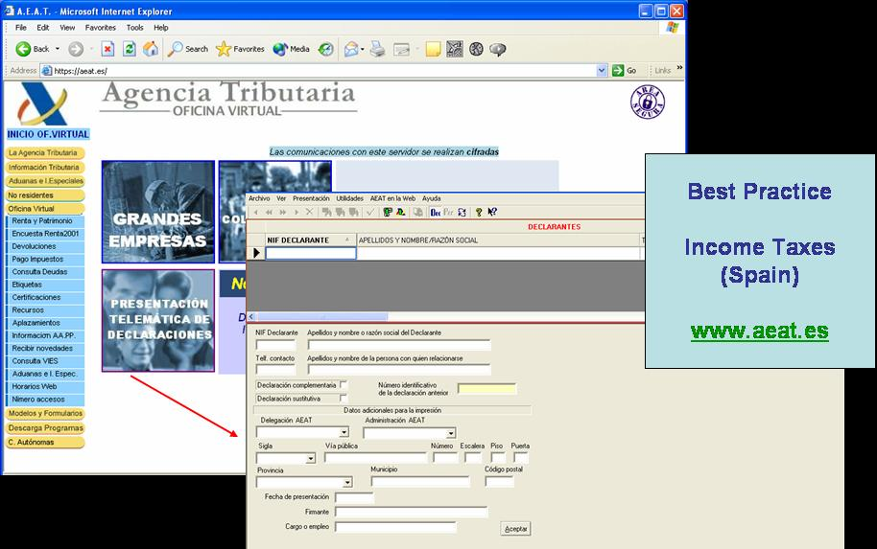
Figure 16: Tax Declaration in Spain

Job Search Services
The responsible authority for job search in Austria is the Ministry of Labour and Economy (Bundesministerium für Wirtschaft und Arbeit). The actual service provider, which is presented as best practice, is the Public Employment Service Austria (AMS, Arbeitsmarktservice). Since 1994 the AMS is an officially recognized company providing services on the basis of public law. The AMS website is a central website providing job offers from all over Austria. Contact information of local branches of the AMS in the different “BundesLänder” and regions is available.

The eJob-Room service of the AMS aims to offer an interactive platform where job-seekers can meet potential employers. Both job-seekers as potential employers receive support in the labour-matching process. Next to online job search by type of job, region or educational background, the AMS also offers additional support with drawing up of CV’s and job applications.

Equal changes for man and women and minority groups are a high priority for the AMS. In this context an adapted service is provided for special target groups such as female job-seekers and older people.

Next to job offers in Austria, a special section is provided (Eures job search) where applicants can look for job vacancies in Europe.

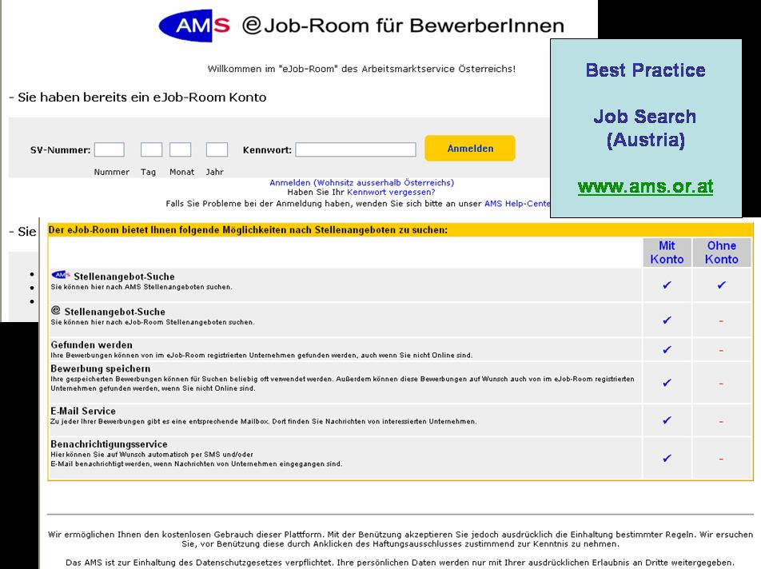
Figure 17: Job Search in Austria

Social Security Benefits
The service social security benefits is investigated by taking into account the following sub-services:
- Child Allowances
- Medical Costs
- Student Grants
- Unemployment Benefits
The best practice presented concerns the reimbursement of medical costs by the medical insurance in France.

Since the re-organisation of the social security in 1996, a convention was signed between the state of France and the national fund of medical insurance for employees to settle the objectives and resources for the functioning and the execution of well-defined actions. The national fund has a double custody as it comes under both the Ministry responsible for Social Security and the Ministry responsible for Economy and Finances.

On a local level the insurance funds are responsible for the registration of the insurants and the daily management. This is an example of a service where the physical service provider is dispersed but where the citizens can consult their files and reimbursement status, which is maintained on local level, from a single access point on national level.

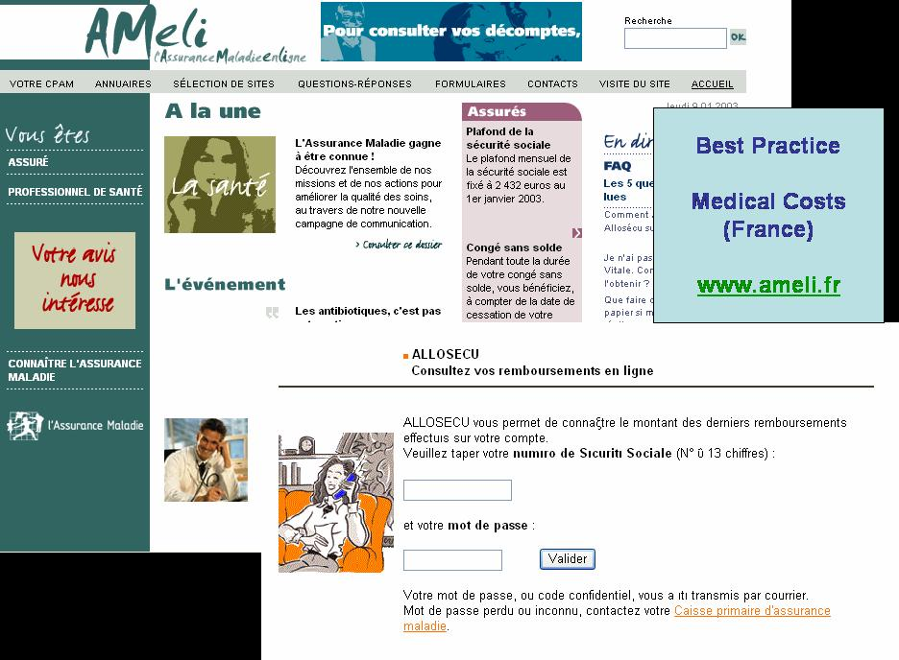
Figure18: Medical Costs in France

Personal Documents
The service social security benefits is investigated by taking into account the following sub-services:
- Passports
- Driver’s Licence
The best practice presented concerns the application and renewal of passports in the UK. In the United Kingdom, the Passport Service is an executive agency of the Home Office, which is the government department responsible for internal affairs in England and Wales. The passport service is responsible for issuing passports to British nationals living in the UK.

The Website of the UK passport service is designed in such way that applying for a passport is simple and convenient. The character of the service implies that a full electronic case handling is not applicable, as a passport needs to be dully signed and provided with a passport photo. However, the UK passport service has reduced the paper work for the applicants to a strict minimum.

On the Website, applicants are guided to complete the passport applicant form correctly. Upon receipt of the application form, the passport service prints the details on an official application form which is posted to the address of the applicant, who then has to sign the form and post it back together with the required documents (e.g. a copy of the old passport) and two passport sized photographs.

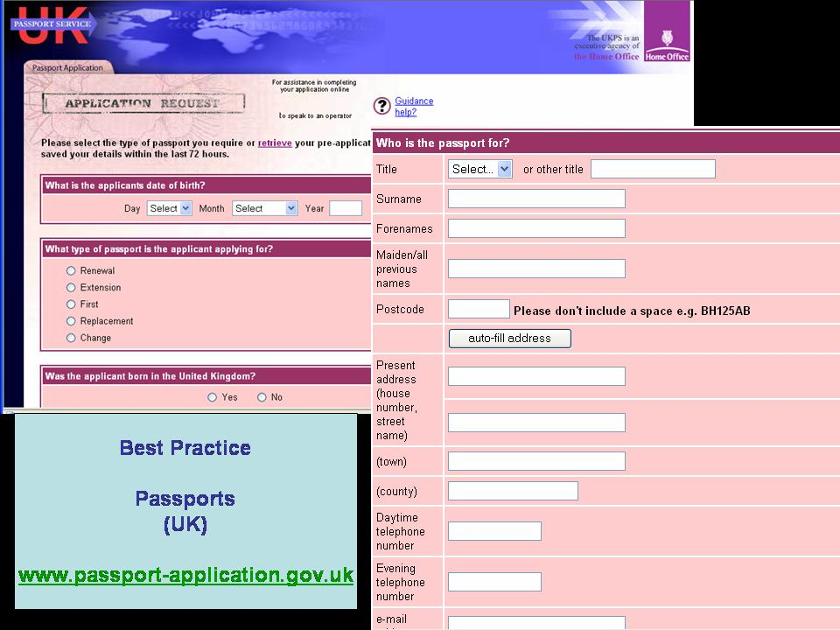Figure 19: Passport in the UK

Car Registration
The SNRA (Swedish National Road Administration) is active in the following task areas:
- sectoral responsibilities: co-operating with and coordinating the work of relevant parties and promoting developments in the road transport system.
- role as a public authority: drawing up and applying regulations for vehicles, driving licenses, road traffic environments and commercial traffic, register management as well as managing state subsidies,
- national road management: developing and managing the state road network in the role of client
- contracted works: carrying out road planning and design, construction, operation and maintenance as contracted by the SNRA and others.
In its role as public authority, the SNRA aims to make it as easy as possible for the individual to contact the authority and fulfill his obligations. The current example is a best practice for car registration offering the citizen a 24 hour online service. In Sweden, as in many other countries, this service is provided on a national level.

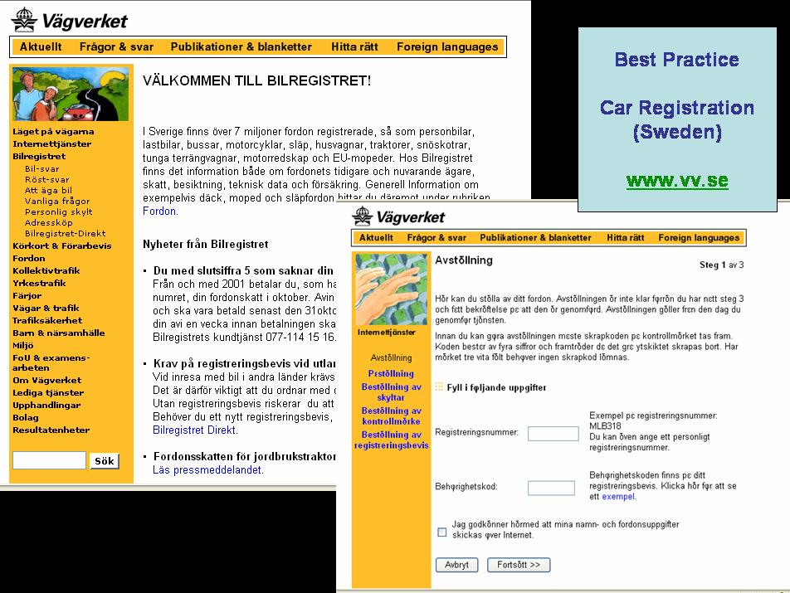
Figure 20: Car Registration in Sweden

Application for Building Permission
In Norway, the administrative responsible level for the service “application for building permission” are the cities and municipalities. The best practice that is illustrated is a local application of the city of Fredrikstad, where citizens can apply for a building permission online. This best practice and the lessons learned in building this application can serve as an example for other Norwegian cities.

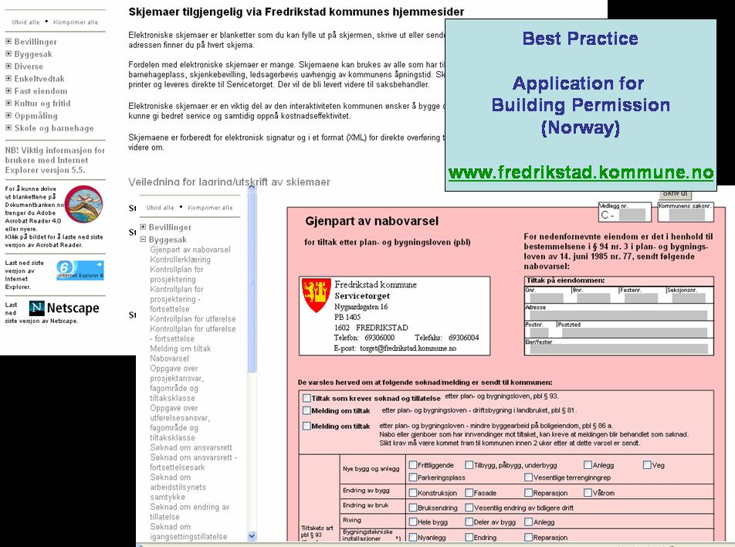
Figure 21: Application for Building Permission in Fredrikstad, Norway

Declaration to the Police
Declaration to the Police is a service that is typically provided on a local level. In the different measurements that have been conducted it was observed that progress in this type of services is in most of the cases realized in countries that invest in e-portal solutions.

This does not automatically imply that the physical service providers are no longer dispersed: it means that the dispersed service providers are reached through a single point of access or a central “virtual” service provider.

The service declaration to the police is illustrated with a best practice in Denmark. This best practice is an example of an e-government solution, where citizens can declare IT-related criminal activities through the Internet. The national unit that is in charge of IT related crime will handle their declaration. If necessary the declaration is automatically forwarded to the local police department authorized for the territory where the crime has occurred.

IT-related crime, ranging from hacking and dealing in illegal software to child pornography and cyber terrorism has grown steadily with the penetration of the Internet over the world. In this example of an eGovernment solution, the same technology that enabled the widespread of criminality in the first place is used to beat the criminality.

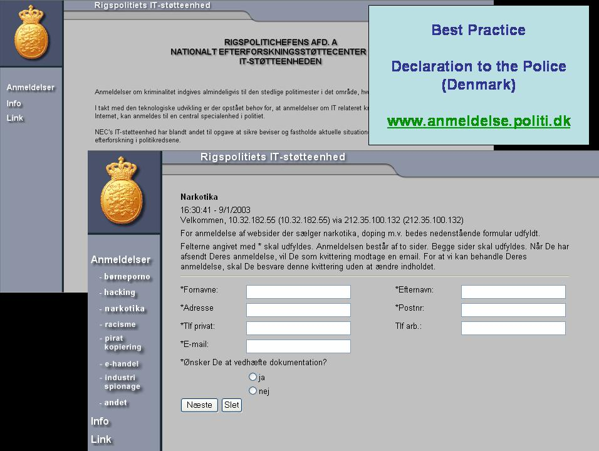Figure 22: Declaration to the Police in Denmark

Public Libraries
The ALEPH network comprises a common catalogue of the national library of Luxembourg and of associated libraries. Currently the network consists of about twenty libraries resulting in a catalogue of more than 400000 entries, but it has all potential to grow both in terms of associated libraries as in terms of catalogue entries (as for the moment electronic catalogues are not yet available for all associated libraries).

The application offers the possibility to search/browse through the database of catalogue entries by author, title and subject. For each entry, the user can display a file with detailed information about the piece of work and the library(ies) where it is available.

A function is provided to make reservations ot borrowing a piece or receive a photocopy of it. Registered users can request to see the details of his/her account concerning payment of transaction such as reservations and photocopies. This function also allows a user to keep his address information up to date.

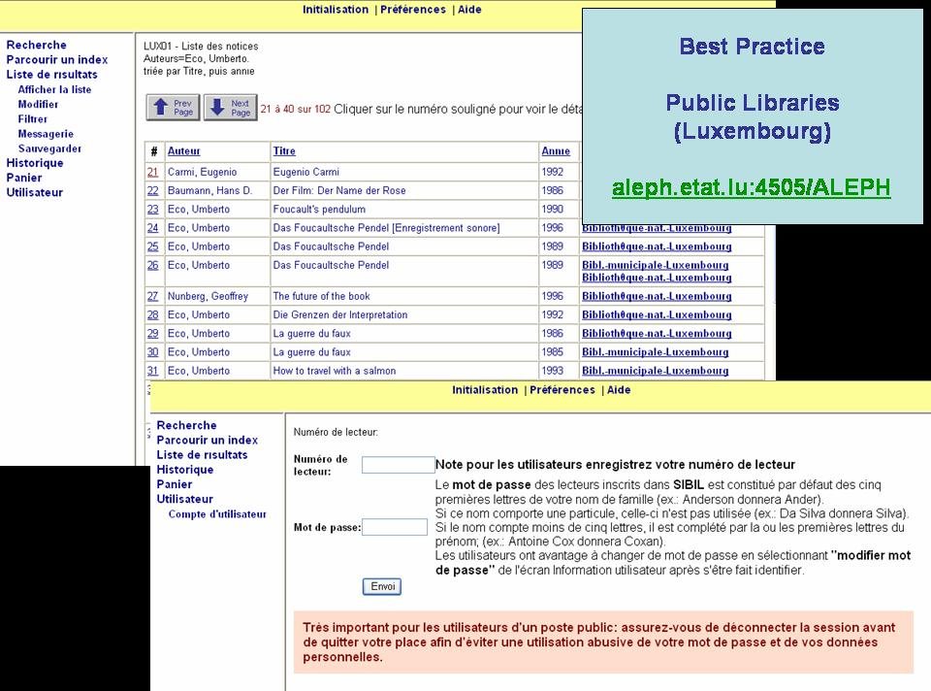
Figure 23: Public Libraries in Luxembourg

Birth and Marriage Certificates
Requesting a birth or marriage certificate is a service with a rather simple underlying procedure that falls typically under the administrative responsibility of cities and communities.

The example that is illustrated here as a best practice is the online counter of the department of civil affairs of the city of Basel (Switzerland). The department is online accessible since May 2001 and offers among others documentation on special events in the citizen’s life such as birth, child recognition, marriage, change of name, decease. Next to documentation, citizens can communicate with the department on a 24h/24h basis to order extracts out of the population register.

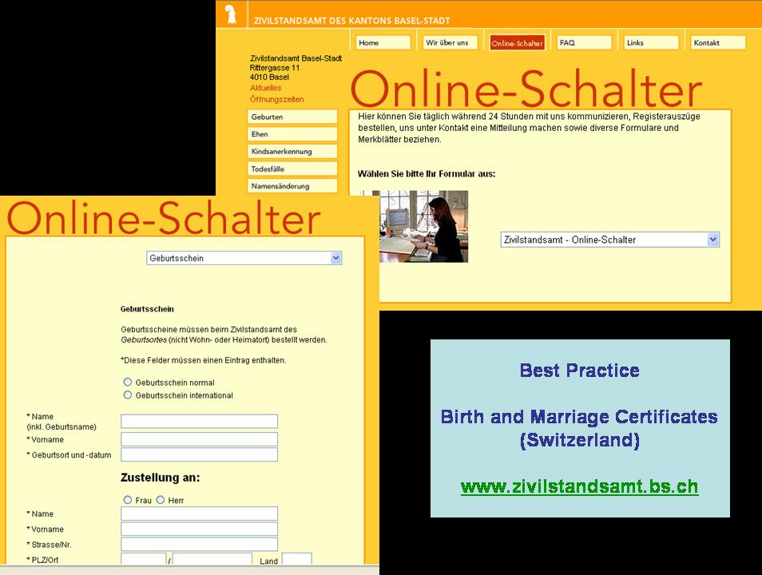
Figure 24: Birth and Marriage Certificates in Basel, Switzerland

Enrolment in Higher Education
In Sweden, all universities and university colleges are public authorities that are directly accountable to the Government. The Government and Parliament are responsible for national education planning, while the institutions themselves are responsible for planning at the local level. The National Agency for Higher Education is responsible for providing guidance data for decisions and assessments at both the national and local level. Its tasks include quality assessments, supervision, reviews, development of higher education, research and analysis, evaluations of foreign education and provision of study information.

The website www.studera.nu which provides information about studies and careers has been constructed on the initiative of the National Agency for Higher Education (www.vhs.se).
The system is based on the cooperation between many organizations, of which institutions of higher education constitute the largest group. The National Board of Student Aid, the National Agency for Services to Universities and University Colleges and the National Labor Market Board are other major participants in the project.

The aim is to provide prospective Swedish students with a one-stop Internet site containing relevant information about higher education opportunities, as well as information about careers and postgraduate studies. Enrolment in higher education is only one aspect that is covered. The website provides all information on how to apply and offers the possibility for students to send their application through the website. Currently this function is not available as the applications for the academic year 2002-2003 have been closed.

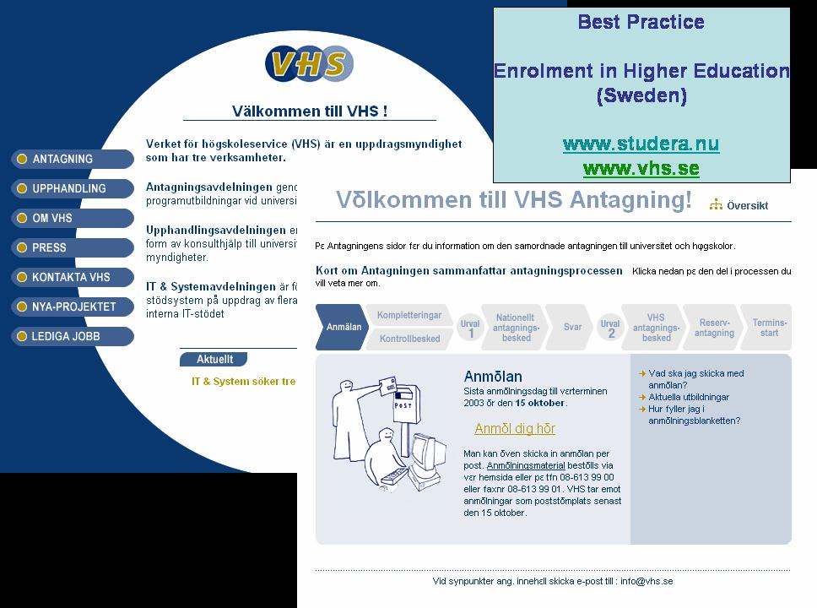Figure 25: Enrolment if Higher Education in Sweden

Announcement of Moving
In a lot of countries citizens have to deal with their local communities to announce their change of address. When existing back-office solutions, such as a national register of the population become web-enabled, progress can be realised quickly.

A good practice of an e-portal with a centralised system of announcement of moving is this Finnish website linked to the national register of the population. When moving in Finland, the Local Register and the Finland Post Corporation need to be notified.

The notification can either be made by phone or by submitting a form on this website. To make the notification through the internet, a Finnish electronic ID card is necessary. This central system of notification enables a quick processing of the change of address towards several authorities such as congregations, vehicle administration, KELA (the social insurance institutions of Finland), the tax administration and the Finnish Defence Forces. In addition, many pension funds, banks, insurance companies, publishing houses and private companies receive new address data straight from the population information system.

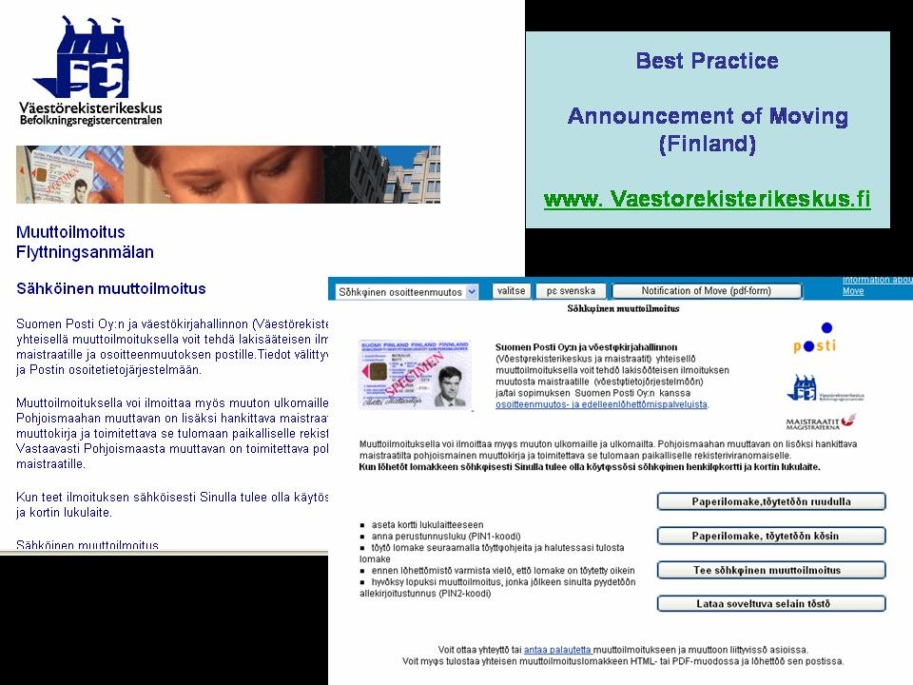Figure26: Announcement of Moving in Finland

Health Related Services
Health related services measure the extent to which a citizen can obtain an appointment in a hospital through the internet. Throughout the three measurements that have been conducted so far, this has been the service with the overall lowest score.

However, the example that is illustrated here is an experiment by the National Cancer Institute in Milan, Italy, investigating to the introduction of electronic forms for making an appointment in the hospital.

For the moment the scope of this facility is limited to patients with sarcoma. Patients that submit the form will receive an appointment by e-mail within 96 hours, which they have to confirm in return.

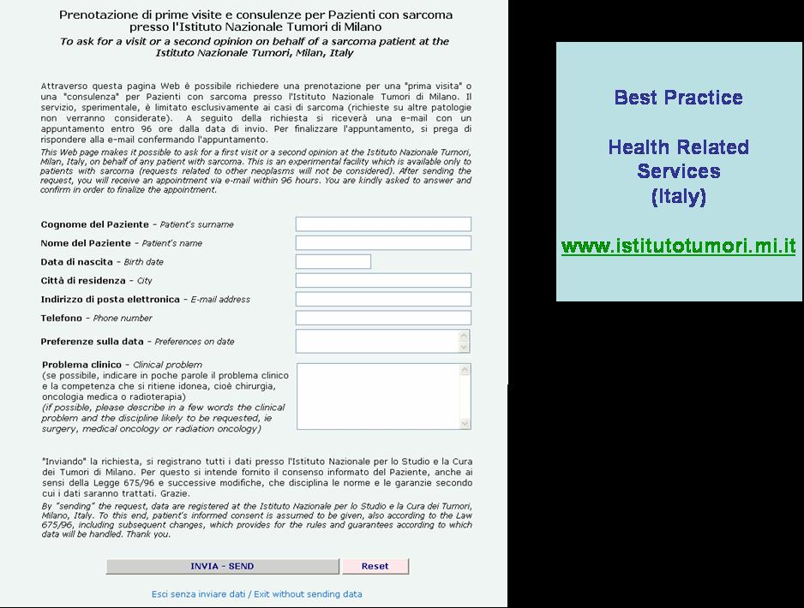
Figure 27: Health Related Services in Milan, Italy

Social Contribution for Employees
The website of the social security administration in Belgium is a good example of the combination of back-office integration and an e-portal solution. This site is a front-office result of a long-term effort that the Belgian government made over the last years linking different databases. It is a unique window for social security in Belgium: the site is developing a transactional link between employers and the social security administration.

The portal site has been designed in such way that each citizen or employer can easily find the answer to all of his questions concerning the Belgian social security.

For employers it is possible to arrange a number of declarations (such as social contribution for employees) through online electronic forms. In the course of 2003 the website will be extended as to enable electronic transactions for citizens as well.

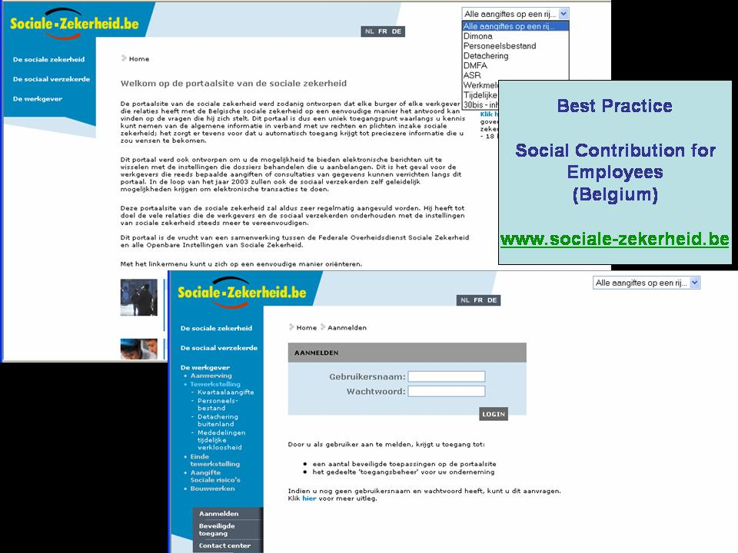
Figure: 28 Social Contribution for Employees in Belgium

Corporate Tax
The Irish Revenue Online Service (ROS), an internet-based electronic tax system provided by the Revenue Commissioners, enables citizens and businesses to file a series of tax returns using the internet.

The facility is an integral part of the Irish Government’s commitment to use the Internet to improve both the quality and speed of its service delivery and can be considered as the flagship eGovernment project in Ireland. Revenue’s online service enables users to access tax details on screen, calculate liabilities, file returns and pay tax liabilities online by laser card or direct debit, 24 hours a day.

The service provides Ireland’s Revenue’s business customers with a quick and secure method for the electronic payment and filing of: monthly and annual payroll returns and employee cessation return details; bi-monthly VAT returns and annual return of trading details; annual business Income Tax and Corporation Tax Returns.

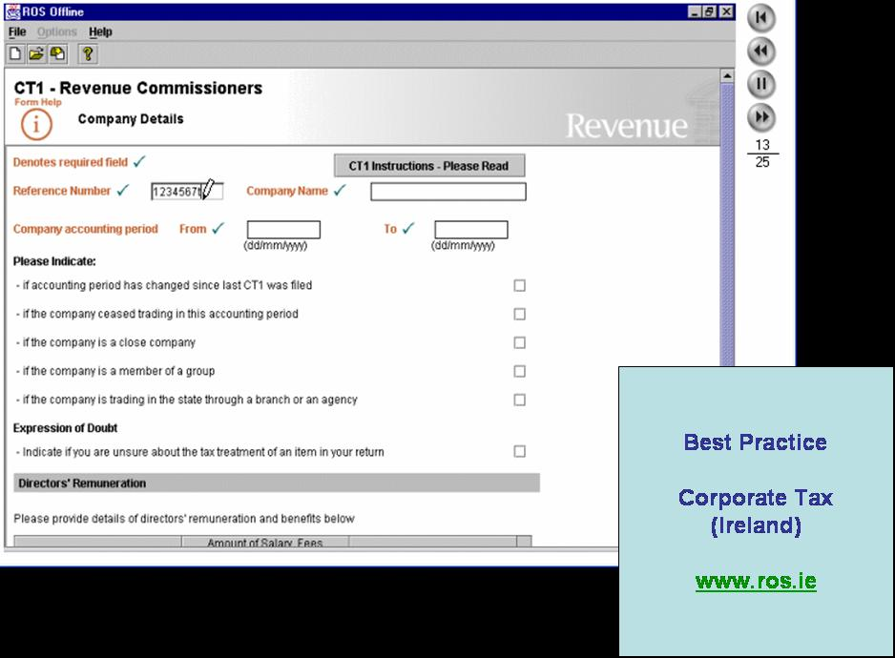
Figure 29: Corporate Tax in Ireland

VAT
The structure of the Icelandic tax authorities is such that three institutions each have their specific working area. The offices in question are the Internal Revenue Directorate, the State Internal Revenue Board and the Directorate of Tax Investigations. Additionally, there are nine district tax offices located around the country.

The Internal Revenue Directorate is in charge of the co-ordination of tax measures between the districts and is the head of tax control of the country. It implements advisory services for the public on tax related matters and manages the operation of computer systems that link the tax authorities.

The best practice example for VAT is implemented by the Internal Revenue Directorate. Next to the possibility of applying for VAT refund online by Icelandic companies, the Website also provides downloadable forms for application of VAT reimbursement to foreign companies.

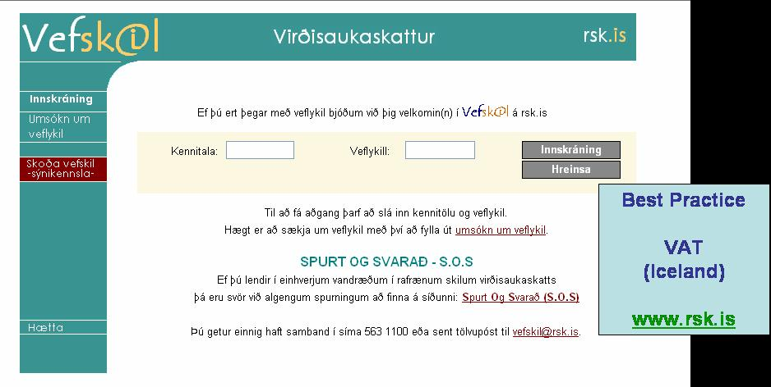Figure 30: VAT in Iceland

Registration of a New Company
The registration of a new company in Greece is organised by the different prefectures (regions) and the authorities in charge are the different regional Chambers of Commerce and Industry. The website below, presented as a best practice, is enabled by the Chamber of Commerce and Industry of Lasithi, the prefecture on Eastern Crete (Greece). Their website gives complete information and all necessary instructions on how to start up a new company according to the type (independent professions, corporation, etc…):

- Information on how to register a new company according to the type of company plus a downloadable form to register your company.
- A 9-step plan to start-up a new company…

Besides information for new companies the website also provides several other services to businesses:
- An online database of all companies in the region according to their type and sector that gives all basic information about the listed companies
- Online forms to ask information or to formulate questions on every business related topic. An answer will be send to your e-mail address.
- Online registration possibility for participation in tradefares and other initiatives organised by the Chamber.
- Online registration possibilities to advertise the weblink of your own company on Chamber’s website.
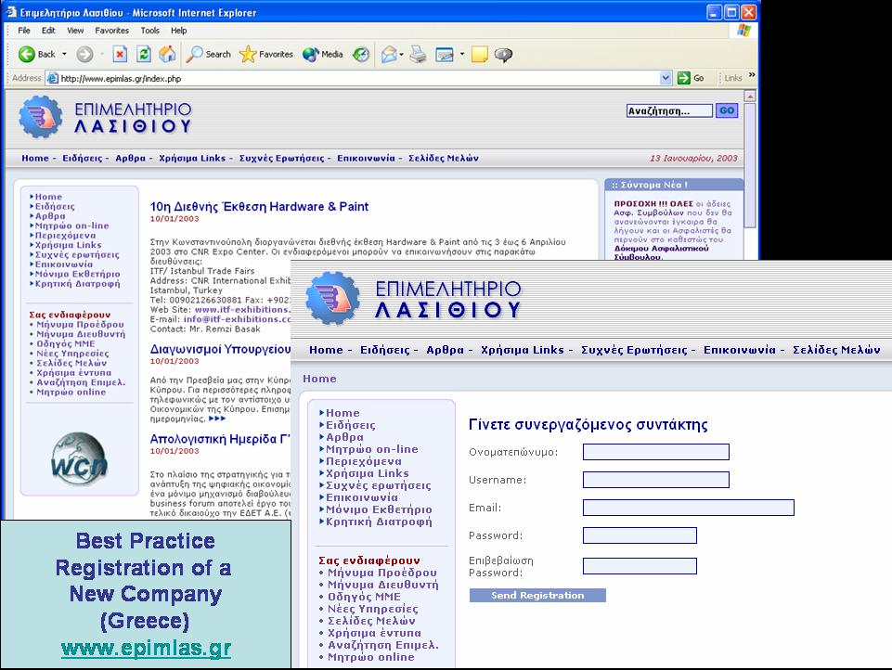Figure 31: Registration of a New Company in Greece

Submission of Data to the Statistical Office
The Federal Statistical Office in Germany is responsible for collecting, processing and disseminating objective, independent and highly qualitative statistical information to all, namely politicians, government, administrative agencies, business and industry, and the citizens in general.

In accordance with the federal state and administrative structure of the Federal Republic of Germany, federation-wide official statistics (federal statistics) are produced in cooperation between the Federal Statistical Office and the statistical offices of the 16 Länder. This means that the system of federal statistics is largely decentralised. In the context of that division of labour, the Federal Statistical Office has essentially a coordinating function, while conducting the surveys and processing the data falls within the competence of the statistical offices of the Länder.

Regarding the monthly trade statistics, the Federal Statistical Office has introcuded the possibility to all registered enterprises to submit these data online via a central website. Today, already more than 3000 enterprises are taking advantage of this opportunity. It is planned to carry out the whole process of collecting and processing official statistics online.

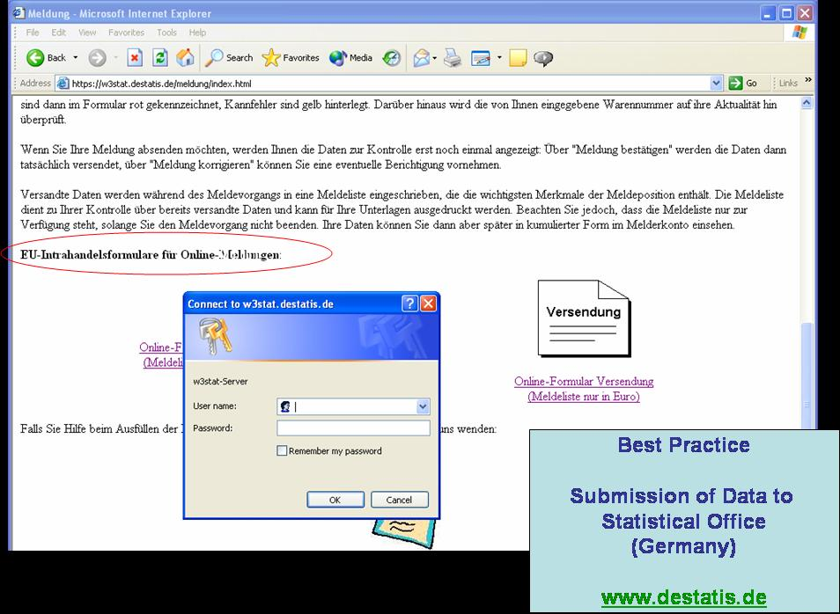
Figure 32: Submission of Data to the Statistical Office

Custom Declaration
Dutch Customs is the controlling administration on the field of import, export and transit of goods. This implies that Customs:

- Control the import, export and transit of goods
- Collect import and domestic excise duties and taxes
- Enforce Dutch and European Union regulations
The Netherlands holds an important position as a transport and distribution country in Europeand outside Europe. This importance is not only on the increase; it also influences the workload of Customs. There is an increase in container transport in the harbor of Rotterdam and also in the expansion of goods and passenger traffic at Schiphol Airport. The growth to a 24-hour economy demands flexibility in the working power of Customs.

The client concept, the development of new automated systems, the national and international fight against fraud and cooperation form a number of spearheads in the Customs policy. Both trade and industry and the Dutch Customs make more and more use of automated information systems to improve their management. The Customs Service invests in particular in the development of systems for processing declarations and combating fraud. The best practice for making electronic declarations, which is illustrated here, has been available already for a number of years already.

Figure 33: Custom Declaration in the Netherlands

Environment-related permits
The best practice that is illustrated for environment-related permits concerns Reachservices, a public service e-government initiative in Ireland. Reachservices offers the possibility to apply for an environmental permit online regardless of the country where the company resides. Registered users can submit their application online and obtain a full electronic case handling. For users who do not want to register, the option is foreseen to download the official application forms and send these by regular mail to the responsible authority.

The Irish Government established the Reach Agency in 2000 to develop a strategy for the integration of public services and to develop and implement a framework for electronic government. Reachservices was developed with this goal in mind and is designed to offer a single gateway to governmental services online.

Reachservices provides the citizens and businesses with quick and secure access to public sector information and interactive services: a wide range of application forms for public services delivered by various public sector bodies such as government departments, state agencies, local authorities and the health sector are available.

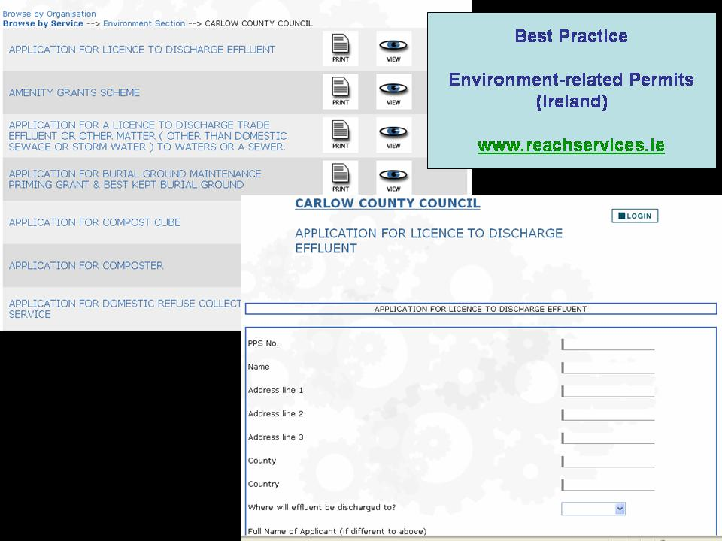
Figure: 34: Environment-related Permits in Ireland

Public Procurement
This Portugese public procuremenet site is administered by Imprensa Nacional - Casa da Moeda, a public limited liability company.

The site Diário da República Electrónico can be accessed in two ways:

- Free access.
- Access for registered members.
When using the free access, you can consult by year, number, publication date, etc. some articles published by the Official Journal.

Registered users get a registration number and a corresponding password.
It allows for a registered user to receive by electronical message interesting news corresponding to his domain/competences. This occurs on the basis of keywords that are transmitted at registration.
The client pays an amount for each package of e-mails (f.e. 15 euro for 50 e-mails).

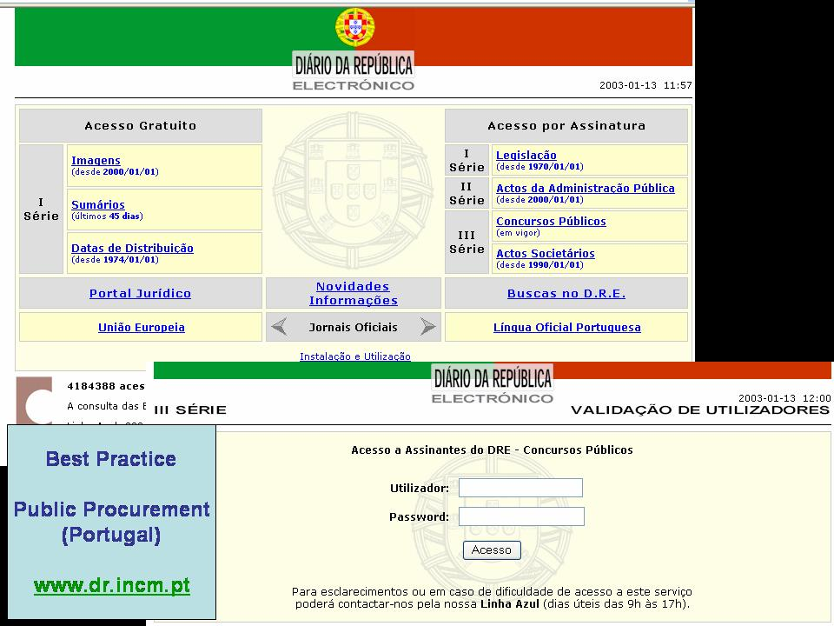Figure 35: Public Procurement in Portugal

Conclusions
Europe is making steady, but slowing, progress on the road to eGovernment.
From the 10.500 public service providers analysed in this study across the 15 EU member states, plus Norway, Iceland and Switzerland, 86% where found online. This shows a growth of 12% in one year (October 2001 – October 2002).

The online sophistication of the analysed public services grew with 15%-point up to an average score of 60%. This represents an important move up the maturity ladder towards the goal of fully e-enabled transactions between citizens and government departments.

Significant differences are observed between the varieties of public services. Overall, services to businesses are more developed than those for citizens (72% against 52%), and interestingly also this gap is growing.

Among the categories of public services, income-generating services (taxes, social contributions) are the most developed (82%) online, followed by registration-services (registration of car and new companies) and returns, such as social security. Services related to documents and permits (drivers’ licence, passports, etc.) are the least developed online (44%).

Organisation of the service provider – either centralized or decentralized – together with the delivery approach of complex or simple services – are key determinators for the position of online sophistication. Each service and service organization needs a specific approach, combining citizen access channels (eg portals) and back-office reorganization.

Although almost all countries have made substantial progress, a wide spread between results for different countries is observed, with country averages varying between 32% and 87%. The great majority of the participating countries improved onlineonline maturity beyond the second level of ‘one-way interaction’ towards ‘two-way interactivity’.

Further growth beyond the stage of interactivity requires a clear vision; a committed leadership to eGovernment as an integral part of a national governmental change programme; and a greater emphasis on the customer. This is required to achieve not just the target of public service delivery online but to deliver the more important aspiration of a transition to a customer focused governmental organization.

Annex 1. The analysed service providers and the percentage of online presence
The table gives an overview of the number of analysed service providers per public service in each country and of the percentage of online presence.

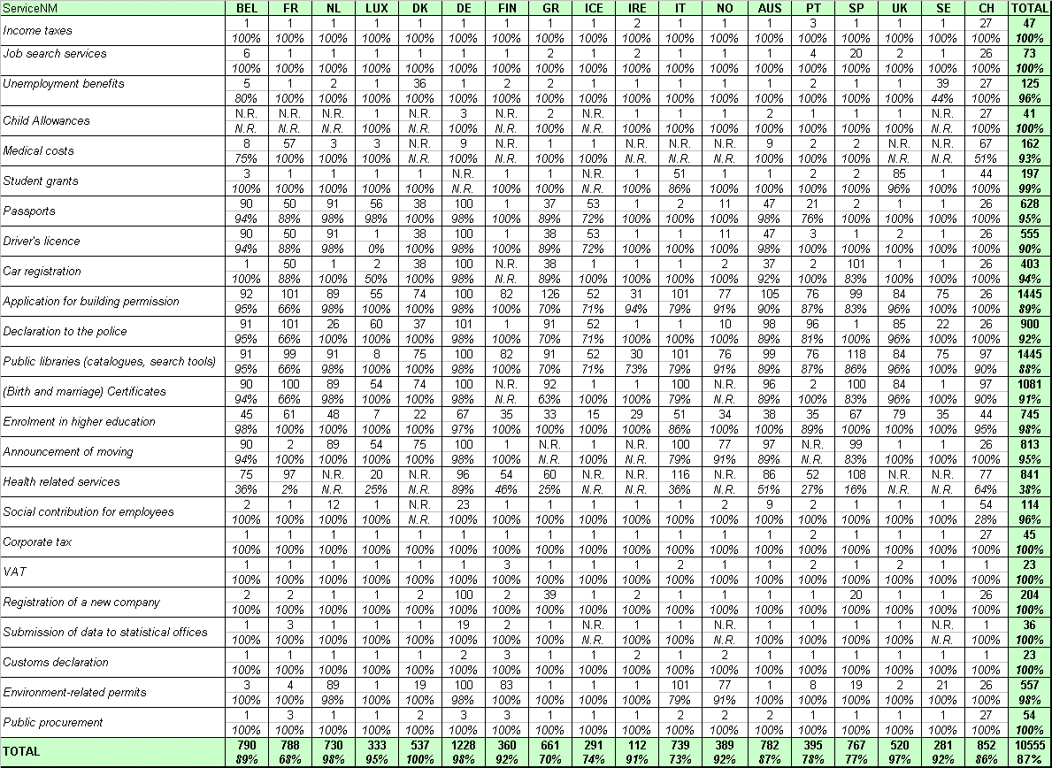

Annex 2: The Service Classification
The graph below gives a detailed overview of the average results and the growth in percentage point of the surveyed public services in the 18 benchmarked countries.

Annex 3: eGovernment Policies in Europe
Country | IT strategy and e-government initiatives | Concrete realizations
Austria | 1998: formulation of the development strategy of the Information Society  April 2000: launching of the eGovernement program  June 2001: creation of IKT Board, instance composed by the CIO's of each federal ministery and responsible of the coordination of the programme implementation | The "HELP" project wishes to develop a unique and homogeneous access for all the information and services provided by the central government, the länders, provinces and the municipalities  www.help.gv.at  Best practices:  - http://jobroom.ams.or.at/entry/as_aut_login.htm (jobsearch services)  - http://www.feldkirch.at/rathaus/bibliothek/bestellung (public libraries)  - http://www.elda.at (social contribution for  - employees)
Belgium | National modernisation plans of the initiatives of the federal government and the Flemish and Walloon regional authorities. Belgium fixed utilisation objectives for the electronic signature, PKI’s and for the development of a web portal of public administrations. | 700 websites  200 electronic forms available for downloading  Best practices:  - http://www.sociale-zekerheid.be (social contribution for employees)  - http://www.vdab.be (job search services)  - http://www.minfin.fgov.be/  - nl_admin/0003/btw_menu.html (VAT)
Denmark | 1994: priorisation of the development of the information society by the government  2000: benchmark of the services offered on line to measure their availability in order to reach 24h/24 7d/7 for the whole | www.danmark.dk constitutes the central access point  www.blankettorvet.dk is intended for private persons  www.indberetning.dk is intended for firms  Best practices:  - http://www.anmeldelse.politi.dk (declaration to the police)  - http://www.aak-ajs.dk (unemployment benefits)  - http://www.toldskat.dk/ (income taxes)
Finland | The Ministry of Internal Affairs and the 19 Regional Councils have a coordination role of the actions taken at municipal level concerning eGovernement | www.suomi.fi constitutes the central access point  The 448 Finnish municipalities offer electronic services.  Best practices:  - http://www.vaestorekisterikeskus.fi (announcement  - of moving)  - http://www.tyvi.org/tyvi.nsf?Open (income taxes)  - http://www.lib.helsinki.fi/finelib/ (public libraries)

France | 1998: launching of the eGovernement strategy with the « Programme d'Action Gouvernemental pour la Société de l'Information » (PAGSI) | www.service-public.fr constitutes the central access point  5 000 sites web de l'administration publique  150 services disponibles en ligne  Best practices:  - http://www.cnamts.fr/loca/loca.htm (medical costs)  - http://www.finances.gouv.fr/douanes (customs declaration)  - www.cnous.fr (student grants)
Germany | 2000: launching of the project "Bund Online" that aims to place at one’s disposal 367 electronic services for 2005 and that represents a budget of 1,6 billions of Euros. | www.bund.de constitues the central access point for the federal level  Most Länders have initiated projects on their own.  µBest practices:  - http://www.arbeitsamt.de/hst/index.html (job search services)  - http://www.aok.de/ (medical costs)  - http://www.destatis.de (Submission of data to statistical offices)
Greece | 1999: white book "Greece and the Information Society"  2000: Operative Program for Information Society (OPIS) aims to augment the penetration of ICTs | www.government.gr constitutes the central access point  Best practices:  - https://www.taxisnet.gr/web/ (income taxes)  - http://www.oaed.gr/ (job search services)  - http://www.epimlas.gr/index.php?option= registration&task=register (registration of a new company)
Ireland | Action Plan "Implementing the Information Society in Ireland"  In this scope, launching of "REACH", eGovernment program that aims to develop smart cards, to implement a Personal Number for access to the Public Service, and to develop a web access platform | www.reachservices.ie and www.irlgov.ie constitute the central access points  www.oasis.gov.ie is intended for the private persons  www.basis.ie is intended for the enterprises  Best practices:  - http://www.ros.ie/ (income taxes)  - http://www.basis.ie (environment-related permits)  - http://oasis.gov.ie/housing/planning_permission /building_a_house.html (application for building permission)
Italy | February 2002: publication of an action plan by the Ministry of Innovation and Technology  This plan aims to promote on line public services, electronic identification and eProcurement for 2005 | www.italia.gov.it is the central access point  Best practices:  - http://www.institutotumori.mi.it (health related services)  - http://www.edisuparthenope.org/prima.htm (students grants)  - http://www.legnano.org/reteciv/biblio/ (public libraries)

Netherlands | Action Plan "Dutch Digital Delta: The Netherlands Online" aspires to promote the use of ICTs through the development of electronic services and eProcurement | www.overheid.nl constitutes the central access point  www.overheid.nl/burgers.html is intended for the citizens  www.overheid.nl/ondernemers-en-organisaties.html is intended for the enterprises  www.overheid.nl/ambtenaren-en-politici.html is intended for the administrations  Best practices:  - http://www.belastingdienst.nl/2001/aangifte2001/frame.htm (income taxes)  - https://www.werk.nl/login/startsessie (job search services)  - http://www.bibliotheeksite.nl/alblasserdam/ (public libraries)
Norway | 2000: launching of "eNorway" action plan that aims to develop the eProcurement and the electronic treatment of the demands of the users in the public administration | www.norge.no constitutes the central access point  Best practices:  - http://www.drammen.kommune.no/bibliotek (public libraries)  - http://www.fredrikstad.kommune.no (application for building permission)  - http://www.samordnaopptak.no/ (enrolment in higher education)
Portugal | The document "Portugal in the Information Society" defines the development priorities of the ICT projects in all the sectors and aims particularly at modernizing the public administration as wel in front-office as in back-office | www.portugal.gov.pt constitutes the central access point  Best practices:  - https://www.dgci.gov.pt/de/main.html (income taxes)  - http://www.dgrn.mj.pt/rnpc/frame_rnpc.htm (registration of a new company)  - http://www.dr.incm.pt/dr (public procurement)
Spain | Action Plan for the development of the information society from 2000 to 2003 for which coordination is assured by the Ministry of Public Administration  The autonomous Communities, Catalonia for example, also launched their proper initiatives | www.map.es constitutes the central access point  Best practices:  - http://www.aeat.es/ (income taxes)  - http://www.ayto-gijon.es/default.asp?Valor=1040 (application for building permission)  - http://www.bibliotecaregional.carm.es (public libraries)
Sweden | March 2000: launching of the project "Virtual Sweden: an Information Society for everyone" that aims to give access to all the Sweden homes to high flow technologies  Promotion of the use of electronic signature in the public administration | www.sverigedirekt.se constitutes the central access point  Best practices:  - https://secure1.ore.vv.se/bilregistretdirekt/Avstallning_1.asp (car registration)  - http://www.lu.se (enrolment in higher education)  - http://194.16.202.10/opac/sv/ (public libraries)
Switzerland | 2000: development strategy for a "single point of contact" through which the users can access to the public services of the central government, the cantons and the municipalities | www.gov.ch constitutes the central access point  Best practices:  - http://job.ai.ch/fachkraft/fachkraft.shtml (job search services)  - http://www.zivilstandsamt.bs.ch/Geburtsschein.htm (Birth and marriage certificates)  - http://kbipac.gr.ch/flmono.htm (public libraries)

Great-Britain | 1999: publication of the white book "Modernizing Government" that initiates the deployment of eGovernement by focusing on the users  the "eminister" and "e-envoy" Office are responsible of the coordination of the different initiatives and are directly connected to the Prime Minister | The "UKGateway" is the services platform of the central government (www.ukonline.gov.uk).  The "Local Councils" also offer many integrated and multi-canal services.  Best practices:  - http://www.worktrain.gov.uk (job search services)  - http://www.studentsupportonline.co.uk/homepage.cfm (student grants)  - www.passports.gov.uk (personal documents – passports)
Luxembourg | The eLuxembourg Action Plan has been presented in January 2001 by the Minister delegated to the Communications. This plan contains eight challenges among which “To put new technologies at the service of the citizens and the companies as well as government officials and public organizations.” | www.eluxembourg.lu constitutes the national egovernment website of Luxembourg  Best practices:  - http://www.aleph.etat.lu:4505/ALEPH (public libraries)
Iceland | One of the main objectives of the Icelandic Government’s vision of the information society is that the Government, with the help of information technology, facilitate access to governmental information and services to level the status of individuals and companies without regard to residence and economic resources. | www2.stjr.is/framt/vision00.htm presents the Icelandic Government’s vision of the information society  Best practices:  - http://www.rsk.is/vefskil/Vefskil_demo_stgr/myndir/vefskil_stgr_demo_skra_1_af_3.gif (social contribution for employees)  - http://www.rsk.is/vefskil/vefskil.asp (income taxes)  - http://www.tollur.is (customs declaration)

The service “social security benefits” is measured on the basis of the following sub-services: unemployment benefits, child allowances, medical costs and student grants
The service “personal documents” is measured on the basis of the following sub-services: passports and driver’s licence
European Comission Flash Eurobarometer 125 "Internet and the public at large" (Gallup Europe)
Source: IDC, 2002

