eGovernment Strategy of the Republic of Slovenia
for the period 2006 to 2010
(SEP-2010)

“eGovernment for effective public administration”

Document copyright

© 2006 Ministry of Public Administration, Ljubljana
All Rights Reserved. Reproduction of this document in part or in full in any manner and in any medium without the written consent of the author is unlawful. Limitations shall not apply to state authorities of the Republic of Slovenia. Violators will be prosecuted pursuant to the Copyright and Related Rights Act and the Penal Code of the Republic of Slovenia.
Acronyms
SEP-2010 (2004) – eBusiness Strategy for Public Administration in the RS for the period 2006 (2001) to 2010 (2004)
EU – European Union
UTS – uniform tax system
G2C – government services for citizens and other natural persons
G2B – government services for businesses and other legal persons
G2G – government to government services
G2E – government services for government employees
MPA – Ministry of Public Administration
CITI – central information and telecommunications infrastructure of eGovernment
AP – eGovernment action plan
MVPDU-IT – state government project leadership methodology in the field of information technology
PPP – Public Private Partnership
AJPES – Agency of the Republic of Slovenia for Public Legal Records and Related Services
OSS – One Stop Shop
ISPO – information system for decision-making support
CIS – central information system for receiving applications, serving and notification
CRP – central population register
IDAbc – Interoperable Delivery of European eGovernment Services to Public Administrations, Businesses and Citizens.
RPE – register of spatial units
IST – priority task of Information Society Technology in the framework of the Sixth Framework Programme
ICT – information and communications technology

Document properties

1. Purpose:
to present the eGovernment strategy of the RS for the period 2006 to 2010
2. Contents: see table of contents
3. Doc. no.: MJU/SEP-2010 – strategy
4. Status: final
5. Version: 3.0
6. Date of version: 11 April 2006
7. Kept by: Republic of Slovenia, Ministry of Public Administration
8. Prepared by: project group for preparation of SEP-2010 pursuant to the Resolution on the appointment of a project group for the preparation of the eGovernment Strategy to 2010 (SEP-2010), January 2006
9. Submitted to: the Government of the RS
10. History of versions:

Version | Date of last change:
1.3 working | 17 Mar. 2005
1.4 working | 5 Apr. 2005
 | 22 Apr. 2005
1.5 working (correction of draft 2.0, at meeting on 31 Jan. 2006) | 6 Dec. 2005
 | 15 Dec. 2005
 | 19 Dec. 2005
 | 31 Jan. 2006, materials for SEP-2010 working group
2.1 working | 3 feb. 2006, working materials including corrections and recommendations of project group
2.2 working | 9 Feb. 2006, working materials with comments and recommendations of the project group at 3rd regular meeting for completion of SEP-2010 taken into account
2.3 working | 13 Feb. 2006, for public release
2.4 working | 7 Mar. 2006, taking into account comments and recommendations which were the result of public release of the strategy and public response to studying the strategy
1.0 draft | 15 Mar. 2006, for MPA collegium and further discussion
2.0 draft | 7 Apr. 2006 Draft taking into account comments of interdepartmental harmonisation and proofreading
3.0 final | 11 Apr. 2006 Draft taking into account comments of Ministry of Justice
Table of Contents

Minister Dr. Gregor Virant: eGovernment for effective public administration 1
1. Satisfied users are the guideline for modern eGovernment – summary of the strategy 2
2. Definition of eGovernment 4
3. Formation of the strategy 5
4. Vision of eGovernment in Slovenia 5
5. The influence of strategy documents and programmes in Slovenia and the EU 5
6. Assessment of state of eGovernment in Slovenia 8
6.1 Introduction 8
6.2 Results of the implementation of eGovernment to 2006 in Slovenia 9
6.2.1 Services and solutions for citizens (G2C) 9
6.2.2 Services and solutions for businesses (G2B) 10
6.2.3 Services and solutions for public administration authorities (G2G) 10
6.2.4 Monitoring of development projects for e-services and solutions in the previous period 10
6.3 Comparison with EU 11
7. Orientations and objectives to 2010 13
7.1 Strategic orientations for the RS and EU in the development of eGovernment 13
7.2 Targets of eGovernment in the RS to 2010 16
7.2.1 Focus the operations of public administration on user needs 16
7.2.2 Increase the quality and efficiency of the functioning of public administration 16
7.2.3 Increase user satisfaction 17
7.2.4 Reduce administrative burdens 17
7.2.5 Increase the transparency of operations of public administration 17
7.2.6 Achieve synergetic effects at all levels of public administration through the use of eGovernment 17
7.2.7 Include the widest circle of users in the decision-making process 17
7.2.8 Optimise the consumption of funds in the field of eGovernment 17
7.2.9 Reduce the burden on human resources in administrative procedures 17
7.2.10 Maintain the level of development of eGovernment 18
7.3 Objective goals of eGovernment 18
7.4 Criteria for decision-making on priority eGovernment projects 19
8. Conditions for directed development of eGovernment to 2010 21
8.1 Conditions for development of eGovernment to 2010 21
9. Central information and telecommunications infrastructure of eGovernment 29
10. Implementation of the eGovernment strategy 31
10.1 Process of implementing the strategy (operationalisation) 31
10.2 Competences and responsibilities for implementing SEP-2010 and reporting 32
10.3 Monitoring the implementation of the strategy 34
10.3.1 Reporting on the progress of eGovernment 34
10.3.2 Methodology for determining the degree of fulfilment of the eGovernment strategy 35
10.4 Management procedures in the field of eGovernment projects 35
10.5 Action 36
11. Sources 38



Minister Dr. Gregor Virant: eGovernment for effective public administration

The set objectives of the Government of the RS and the Ministry of Public Administration, to achieve higher quality and more efficient operations in public administration, its open and transparent functioning and user orientation, will be realised through several measures. eGovernment is the key to achieving these goals. The detailing of the strategy of eGovernment for the period from 2006 to 2010 is an indispensable element on this path and a signpost with clear goals and competences. We do not see eGovernment simply as electronic support to existing processes, but as an opportunity to change these processes, tasks and ways of thinking so that work in public administration will be more efficient and that our relations with our clients, citizens, other natural persons, businesses and other legal persons will be friendlier.
The strategy is therefore an inducement to further thinking on changes in public administration using modern information and communications technologies which will have a positive effect on citizens in their dealings with public administration. Such thinking and activities will have to reach everyone. We therefore believe that in the realisation of eGovernment there is enough room for everyone wishing for positive change.
eGovernment will enable one-stop access to services, without unnecessary losses of work time and the ill humour which can be caused by unnecessary administrative complications. It will provide links to official records so that public employees will be able to access the required data without the assistance of citizens. It will also continuously reduce administrative burdens, achieve a high level of transparency of public administration and increase the level of trust in its functioning.
The eGovernment strategy for the period from 2006 to 2010 is intended for a wide range of readers, from the general public and professionals. In terms of its narrow range of content, eGovernment mainly involves modern technologies, electronic services and information systems. In terms of its wider range of content, as already mentioned, it reaches into numerous spheres in which changes (e.g. legislative, staffing) are required. Thus the strategy provides an opportunity for every reader to make their own contribution to better public administration through the use of eGovernment.

Satisfied users are the guideline for modern eGovernment – summary of the strategy
In 2006, Slovene eGovernment (electronic public administration) enters a new period of development with effective and visible new results from the period of the first eGovernment strategy in public administration and other influential strategies and programmes up to 2006. According to various criteria it has achieved a level of development comparable to or higher than that of other EU states. It has established an efficient and reliable information and telecommunications infrastructure for electronic services for citizens, other natural persons, businesses, other legal persons and public employees. The eGovernment portal and others offer information and electronic services; the results of their use are visible, which encourages further work in this area. The numerous measurements, comparisons and results are at this moment entirely encouraging, but are not the most important factor. The most important factor or global objective, and one which will be the primary driving force behind the further development of eGovernment, are satisfied users. Their satisfaction can be achieved through friendly, accessible, simple and affordable e-services which they require most often for their life events (e.g. childbirth, marriage, purchase of real estate, company registration etc.). eGovernment is therefore about people. In order to continuously increase the quality of life and satisfaction of eGovernment users, it will be necessary to ensure its continuous development, which requires public administration to provide the following:
- the carrying out of rationalisation, optimisation and standardisation of administrative operations
- monitoring the effects of upgraded operations
- adaptation of legislation
- solution of organisational and legal/formal issues
- development of modern business models for the development of eGovernment
- transition of administration from a performer of administrative procedures to a service provider
- opening and linking of information sources within administration in order to provide more efficient and cheaper services
- possibility of citizens and non-governmental organisations participating in the planning and functioning of eGovernment
- interoperability of solutions, services and data
- carrying out informatisation projects using modern and tested technologies
- training of all public employees who will use eGovernment solutions
- constant internal and external promotion of eGovernment
- funds for the operation and maintenance of eGovernment

The purpose of the eGovernment strategy for the period 2006 to 2010 (abb.: SEP-2010) is to determine a framework and goals for further realisation of new and already established eGovernment activities, with an emphasis on user satisfaction, rationalisation of administrative operations and modern electronic services which will enable a higher quality of life and give administration a more friendly face in contacts with users. The priority tasks listed herein are part of the Work Programme of the Government of the RS for 2006, and as part of that programme the work of the Ministry of Public Administration for 2006 (hereinafter: MPA), which includes several targeted eGovernment activities based on four main objectives:
  - high-quality and efficient operations
  - open and transparent functioning of public administration
  - an efficient system of public employees and efficient management of human resources
  - user orientation of public administration
The SEP-2010 strategy takes into account modern guidelines and initiatives which have been passed at EU level and which lead to success throughout the EU. It also takes into account the initiative “i2010 – A European Information Society for Growth and Employment” and the most recent Ministerial Declaration and guidelines from the ministerial conference “Transforming Public Services, 24 November 2005, Manchester, UK”.
With the strategy to 2010, a new era begins, as well as new tasks for everyone involved in the implementation of eGovernment. The greatest challenges will be faced by the Ministry of Public Administration, which will have the role of co-ordinator, methodologist, promoter and executor of the development of eGovernment. Difficult tasks will also be performed by all public administration authorities (state authorities, local self-government) which will assist in the opening of key administrative registers and revising procedures for more efficient work in administration. Through their combined efforts they will create a solid basis for this and for better e-services. The results of their joint labours will contribute to the improvement of services for citizens and businesses with increased time, spatial and varieties of access to the services of public administration, to the rationalisation of administrative procedures, the improvement of the administrative environment for employees in the public administration and to faster exchange of data between public administration institutions with the introduction of suitable legal bases and information standards.
The strategy presented below gives a vision of eGovernment, the influences of other domestic and EU strategies and programmes, a summary assessment of the previous period of eGovernment, strategic orientations and objectives to 2010 and the necessary conditions for the implementation of the strategy. In addition to developmental content and priority tasks for the coming period, it also includes mechanisms for implementation and a system for monitoring the progress of the eGovernment strategy, which is a vital instrument for establishing the actual level of progress. The figure below presents the components of the strategy:

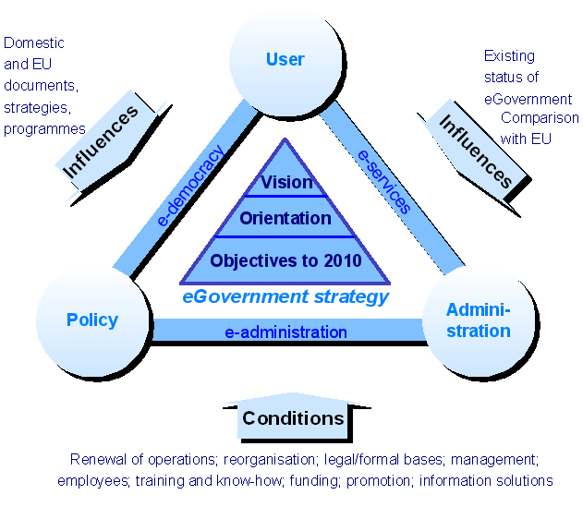
Figure 1: Contents and components of the eGovernment strategy to 2010

Definition of eGovernment
eGovernment, or electronic public administration, is a form of carrying out business processes in public administration authorities which is based on the use of modern information and communications technologies and is oriented towards the end users (citizens, businesses, public employees). It is intended to achieve the increased accessibility, transparency and quality of user services and improved internal efficiency. eGovernment includes ensuring the participation of various groups and institutions in discussing topics of national importance and the functioning of state and public administration. In order to do so, various methods are employed for the automating of tasks, especially for external (requesting services, distribution of products, e-democracy), as well as internal communications (linking records, automatic processing).
The expression eGovernment also includes constant adjustment of organisational, legal and technical frameworks in order to provide the most efficient possible implementation of such business processes.
The introduction of eGovernment in all segments will allow the achieving of important long-term synergetic effects in connection with the transparency, rationalisation and flexibility of operations.

Formation of the strategy
The formation of the SEP-2010 strategy goes back to March 2005. The project group began by forming the vision and strategic objectives of eGovernment and continued by preparing other key contents of the strategy. By the end of 2005 a draft had been prepared and several key documents had been studied from the fields of e-business, national strategies and programmes, and EU guidelines and initiatives. At the beginning of 2006 the project group was expanded with professionals, representatives of state authorities, who were appointed by a Resolution of the Government of the RS. They studied the draft strategy and gave constructive advice as to what could be added. In the opinion of the project group a good proposal for the eGovernment strategy was created, which was suitable for public release and discussion.
The public release was followed by interdepartmental harmonisation, in which the majority of state authorities offered their opinions and comments.
This draft of the SEP-2010 takes into account the comments of the SEP-2010 project group, the various public groups and interdepartmental harmonisation. These were mainly constructive and contributed to improving the quality of the document. The materials have also been proofread.

Vision of eGovernment in Slovenia
Slovenia will strive to advance the progress of eGovernment, according to both the established comparative criteria of the EU and the less measurable but still exceptionally important results of eGovernment: user satisfaction, reduction of administrative burdens, innovative solutions, new business models, co-operation with various persons and other countries, the implementation of good practice, the forming of a knowledge database, rationalisation of internal operations, qualification of all participants for the use of eGovernment, standardisation and central management of eGovernment, interoperability etc. With the implementation of the eGovernment strategy, new opportunities, new services and new models of administrative operations will appear. eGovernment understood in this manner will become much more than support for the existing administration; it will become an important factor in the sustainable development of administration in Slovenia in general.

VISION of eGovernment in the RS to 2010
To provide citizens and businesses with friendly, simple, accessible and secure electronic administrative services, e-democracy applications and information available on the Internet anytime anywhere, for all of their life events.

The influence of strategy documents and programmes in Slovenia and the EU
This eGovernment strategy was influenced directly and indirectly by numerous strategy and programme documents, e.g.: the Development Strategy of Slovenia, the Reform Programme for Achieving the Lisbon Strategy Goals in Slovenia, the Programme of the Government of the RS and the Programme of the Ministry of Public Administration, and the Framework of Social and Economic Reforms for Increasing the Welfare in Slovenia. Guidelines, studies and initiatives at EU level also contributed: i2010 – A European Information Society for Growth and Employment, Program IDAbc, eGovernment beyond 2005, eGovernment in the EU in the Next Decade, eGovernment Studies 2005 – Helping to Light the Way for eGovernment in Europe towards 2010. Various good practices and guidelines were also taken from past projects and experiences, e.g. the Strategy of the Republic of Slovenia in the Information Society, the National Development Plan of the Republic of Slovenia 2001-2006, the e-Business Strategy for Local Communities, The Strategy for the Functioning and Development of Administration in the Republic of Slovenia on the Internet and other strategy documents.
In addition to the objectives in the field of eGovernment which are included in the Work Programme of the Government of the RS for 2006 and have already been summarised briefly in the introduction, three emphases from the reference strategy documents are presented below.
During the drawing up of SEP-2010 the Ministerial Declaration “Transforming Public Services, 24 November 2005, Manchester, UK” and guidelines from the ministerial conference “Signposts towards eGovernment 2010” were issued. Both documents outline the major advantages and opportunities of eGovernment and emphasise four aspects of its further development, and within these individual objectives for which it will be necessary to provide clear benchmarking.
- Inclusion of all citizens in eGovernment
  - By 2010 all citizens, including socially disadvantaged groups, will have become major beneficiaries of eGovernment.
  - By 2010 European public administrations will have made public information and services more easily accessible through innovative use of ICT and through increasing public trust, increasing awareness of eGovernment benefits and through improving skills and support for all users.
- Successful and efficient administration using eGovernment solutions and services
  - By 2010 eGovernment will be contributing to high user satisfaction with public services.
  - By 2010 eGovernment will have significantly reduced the administrative burden on businesses and citizens.
  - By 2010 the public sector will have achieved considerable gains in efficiency through the use of ICT.
  - By 2010 European administrations will have significantly increased transparency and accountability wherever possible and relevant through innovative use of ICT.
- Delivering high impact services designed around customer needs
  - By 2010 all public administrations across Europe will have the capability of carrying out 100% of their procurement electronically, where legally permissible. Thus they will create a fairer and more transparent procurement market for all companies independent of a company’s size or location within the single market.
  - By 2010 at least 50% of public procurement above the EU public procurement threshold will be carried out electronically.
  - Over the period 2006-2010 member states will focus their efforts on delivering those high impact services in Europe which will contribute most to the achievement of the Lisbon Agenda.
- Important factors and conditions which will enable the implementation of eGovernment in the planned directions
  - By 2010 European citizens and businesses shall be able to benefit from secure means of electronic identification that maximise user convenience while respecting data protection regulations. Such means shall be made available under the responsibility of the member states but recognised across the entire EU.
  - By 2010 member states will have agreed a framework for reference to and where appropriate the use of authenticated electronic documents across the EU, as appropriate in terms of necessity and applicable law.
Similar emphases and aspects, such as those presented in the Ministerial Declaration, are also discussed in other documents from the past two years, such as “eGovernment in the EU in the Next Decade – the Vision and Key Challenges” (August 2004). In this document eGovernment is discussed as a tool for the improvement of administration in the broadest sense. eGovernment is being established at the core of administrative changes and reforms, in which technology has the role of a strategic tool used to modernise structures, processes, and regulations, which at the same time enables changes in the field of human resources and public sector culture. The vision is therefore that of better administration through the use of eGovernment and on that basis increased value for citizens and businesses. In order to achieve this, four main aspects will have to be taken into account:
- The increasing importance of knowledge management in administration, management and democratic processes
- Focussing on the needs of citizens and businesses for the services of public administrations
- Inclusion and awareness of the increasingly important role of intermediaries in the chain of providing administrative services and in democratic processes
- The importance of the interoperability of organisations, processes, resources (human, funding) and information solutions in order to provide more efficient public administration
From these four aspects we can establish that in future eGovernment will have to be based more on knowledge, user requirements, distribution and linking.
From the definition of eGovernment it follows that local self-government is a part of eGovernment, which has as its basis the eGovernment Strategy for Local Self-Government (abbr.: ESLS). The extensive field of local eGovernment is covered by separate strategy documents, while the points in common are also included in this strategy. ESLS proposes five groups of projects: basic projects, internal operations of municipalities, user services, training and equipping, and support for social activities. The basic projects as outlined in the ESLS include the upgrading of the business processes of public administration and the provision of organisational, legal and technical means for the implementation of eGovernment in local communities. The results of these projects will be useful for the state administration and for local self-government, and they will have to be carried out with the close co-operation of both sides. The ESLS Action Plan was drawn up on the basis of the ESLS, which discusses three directions of the development of eGovernment in further detail: 1. upgrading the on-line e-services of the state administration, 2. development of central on-line e-services for municipalities, 3. development of local applications. The first of these is also included in the action plan among joint solutions and e-services of public administration and local self-government.
Due to their complexity, importance and size, the joint or basic projects discussed in the ESLS or the ESLS Action Plan will be a part of the eGovernment projects which will result from SEP-2010. The state administration will provide a central infrastructure (see item 9, Central information and telecommunications infrastructure of eGovernment with agreed conditions of use.

Assessment of state of eGovernment in Slovenia

Introduction
Over the period 2001 to 2006 the Slovene public administration underwent several organisational changes. eGovernment developed in parallel and in accordance with them and with the existing possibilities, and was marked in that period by strategy and programme documents such as SEP-2004, the eGovernment Strategy for Local Self-Government, the Strategy of the Republic of Slovenia in the Information Society and others. Numerous successes were achieved up to 2006, while at the same time all participants faced new challenges and failures within eGovernment projects. A critical assessment, the sum of all of our experiences and acquired knowledge, represents the driving force for the new era of the SEP-2010 strategy.
Fields and activities of eGovernment up to 2006 which were successful and achieved the objectives of the strategies and programmes:
- eGovernment portal with services and information for citizens and businesses and also for internal administration operations.
- Establishment of a central mechanism for monitoring eGovernment projects and the eGovernment Action Plan.
- Reliable information and telecommunications infrastructure for the state administration.
- Implementation of complex interdepartmental projects (e.g. One Stop Shop – e-OSS, Central Register of the Population e-CRP, linking of records, MDDSZ-CVI-CRP, described in more detail under item 6.2).
- Establishment and functioning of infrastructure elements of eGovernment (fast public administration communications network – FCOM, Data Centre – PDC, joint information solutions, central modules, central information solutions – CIS, central registers etc.).
- eGovernment progress comparable with other EU countries (describe in more detail under item 6.3).
- Noticeable savings in public administration owing to effects of modern e-services (e.g. reduction of the number of certificates issued) and interdepartmental information projects.
- Inclusion of all competent authorities in a unified eGovernment group in order to increase level of information and more uniform development of eGovernment.

Fields, activities and experiences of eGovernment up to 2006 which offer opportunities for improvement and which we should take into account in the upcoming period in the strategy to 2010:
- Lack of mechanisms for taking measures in response to poor responsiveness of participants in eGovernment projects and unclear competences.
- Business process optimization and reengineering did not parallel development of eGovernment.
- Insufficient promotion of eGovernment and consequently insufficient level of use of e-services.
- Decision making on priority of projects did not always occur in accordance with strategy, but was dependent on momentary conditions, possibilities and situations.
- Difficulties with harmonisation in interdepartmental eGovernment projects.
- Lack of a uniform eGovernment architecture, interoperability framework and open standards for eGovernment projects.
- Lack of organisational, semantic and technical standards for linking databases, applications and information systems – interoperability of frameworks.
- Different technical platforms for eGovernment solutions.
- Delays at the beginning of implementation of eGovernment projects due to complications in public procurement procedures and overdue adoption of the legal bases which are a condition for modern e-services.
- Effects of eGovernment solutions and services are not monitored regularly.

Results of the implementation of eGovernment to 2006 in Slovenia
The main results of the implementation of eGovernment to 2006 are presented below. The results achieved in this period have to be viewed from various aspects and not just according to EU benchmarks. The established EU methodology for determining the level of development of eGovernment services for instance does not take into account G2G e-services (e-services within public administration), in which Slovenia due to its comparative advantages (central registers, central eGovernment modules, standardised identifiers etc.) is highly active. G2G e-services have been implemented in Slovenia in the past which enabled the rationalisation of public administration in individual areas (described in more detail in item 6.2.3). The first noticeable savings in the field of eGovernment were achieved with these services (e.g. reduction of the number of certificates issued by over 30% per year).

Services and solutions for citizens (G2C)
The national eGovernment portal is now functioning, which supports 16 life events for citizens and five life events for businesses, as well as nine larger informational and service portals. In future it will be necessary to provide co-ordination of their contents, linking and standardisation.
The electronic on-line services currently available for citizens are: land register, access to one’s own personal data on the basis of a personal digital certificate, land cadastre, building cadastre, RPE, court register, data information service (ISPO), information of public character, Klasje classification server, interactive atlas, register of regulations.
In the period to 2006 the informatisation of the central registers was carried out, and the register of the permanent population was also revised. Both of these achievements form an excellent basis for further services.
In addition to e-taxes for natural persons, electronic services for citizens also include 36 e-services which are processed using the central information system (CIS) for receiving applications, serving and notification.

Services and solutions for businesses (G2B)
The following electronic services are available for businesses: land register, land cadastre, buildings cadastre, RPE, records from the real estate market, register of companies, e-customs, interactive atlas, register of regulations, e-taxes for businesses, e-annual report of AJPES, e-employment for businesses, electronic services for notaries public, 13 e-applications which are processed using the central information system (CIS) for receiving applications, serving and notification. One especially notable project is e-OSS, which enabled the one-stop registration of individual sole traders in the middle of 2005. The first results were followed by various upgrades of e-OSS, and further additions are planned for the coming period.

Services and solutions for public administration authorities (G2G)
Several G2G projects were carried out in order to establish connections between state authorities, other institutions and their records, and solutions e.g.: link between the information solution of the Pension and Disability Insurance Fund, the Government Centre for Informatics and the Central Population Register – ZPIZ-CVI-CRP; link between the records of the Ministry of Labour, Family and Social Affairs, the Government Informatics Centre and the Central Population Register – MDDSZ-CVI-CRP; link between the land cadastre and the CRP, link between the CRP, AJPES and the Statistical Office of the RS, and the Ministry of Finance and the Ministry of Agriculture, Forestry and Food with the Register of Spatial Units (RPE).
These and related projects have brought about numerous benefits: more than 900,000 searches in the CRP per year, linking of increased number of users with RPE and the land cadastre, reduction of requirements for certificates – by more than 30% per year, electronic sessions of the Government are available to employees in public administration.

Monitoring of development projects for e-services and solutions in the previous period
The progress of eGovernment projects through which the listed e-services and solutions were implemented during the period of the SEP-2004 strategy was monitored from a single point pursuant to the eGovernment Action Plan. The co-ordination of the preparation and implementation of that plan was directed by the former Government Centre for Informatics. The number and progress of numerous projects was monitored under this plan. The most recent data on this are available for November 2004. Records were kept on 146 eGovernment projects. Their number increased by 72, or 49.32 percentage points in comparison with November 2002. An increase in the number of projects in November 2004 can also be seen in comparison with November 2003 (by 24 projects or 16.44 percentage points). A similar monitoring system, which will take into account the good practice from the previous strategy period, and will also include new mechanisms and procedures, will be used in future in order to monitor the progress of eGovernment to 2010.
The graph below shows the distribution of eGovernment projects according to development stages and three measurement periods (November 2002, 2003 and 2004).

Figure 2: Projects in the eGovernment Action Plan according to status (November 2004)

Comparison with EU
In the field of implementation of eGovernment, Slovenia has made great progress in comparison with other countries of the EU. The latest assessments were published by the European Commission in March 2005. Assessments were performed in 25 EU countries plus Norway, Iceland and Switzerland. The results of the research in these 28 countries indicated that Sweden (89%) and Austria (87%) have the most developed on-line services. Slovenia is ranked in 15th place, but lies only behind Estonia among the new member states. In comparison with the EU-25 Slovenia lies in 13th place and is above the EU-25 average:
Figure 3: Comparison of implementation of e-services among countries of the EU
Slovenia is significantly above average in e-services for citizens, where it ranks in 6th place among the EU-25. A comparison is shown in the following figure:

Figure 4: Comparison of implementation of e-services for citizens in the EU-25
Taking into account recent development and growth trends in this field, according to existing EU methodology we can expect Slovenia to be ranked in the top ten countries of the EU-25 in one year. Slovenia will achieve a higher ranking for G2B services, in which we are currently lagging behind, while for G2C we are already among the leading countries. In future we can expect changes in methodology, since it does not at present take into account all aspects of eGovernment (e.g. G2G services, and there is no standardised package of e-services for all countries). Measurements in Slovenia will be adjusted in accordance with changes in methodology.
Monitoring only the number or level of development of eGovernment services is not sufficient to establish the actual state of eGovernment; its use has to be monitored as well. Measurements of use have been carried out in the EU which could be reasonably compared with the level of use of eGovernment, but up-to-date and comparative data are unfortunately not available. Therefore below a comparison is given between the data which are available, i.e. between the level of development of eGovernment for citizens (G2C) and the percentage of households which use the Internet (regular users) in individual countries (data for 1st quarter 2005). Slovenia is ranked in the lower right quadrant and still has a great deal of development potential. At the same time it can be established that Slovenia has a relatively appropriate level of development of eGovernment with regard to its level of household Internet use. Only Finland and Austria are ranked higher among countries with similar percentages of households which are regular Internet users

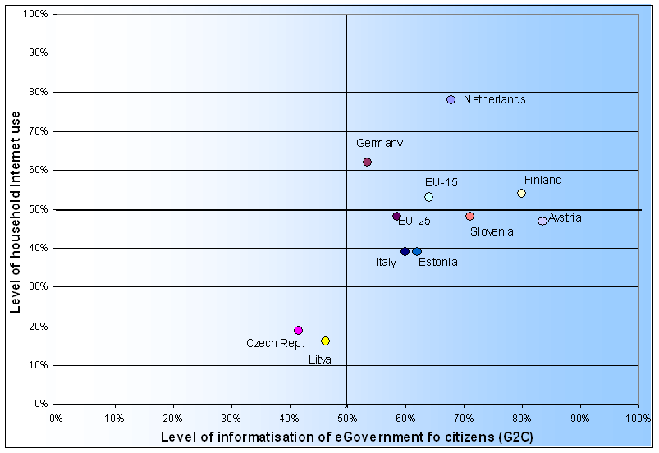
Figure 5: Comparison of implementation of e-services for citizens in the EU-25

Orientations and objectives to 2010

Strategic orientations for the RS and EU in the development of eGovernment
The most important strategic orientations for eGovernment to 2010, which follow from the vision and mission of eGovernment and the listed strategy documents and are the guidelines for determining further eGovernment objectives, tasks, projects and activities in Slovenia are the following:
- User-centric eGovernment. The development of eGovernment will follow the actual needs for its use, wherein the concept of users includes three groups: 1. citizens and other natural persons who require the services of eGovernment, 2. businesses and other legal persons and 3. employees in public administration. The fundamental mechanism for brining administration closer to users will be the constant determination of their needs and level of satisfaction.
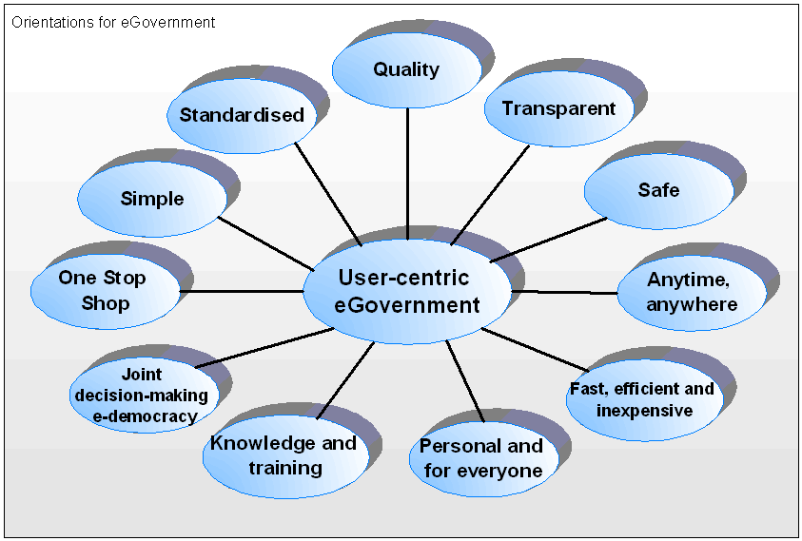

- One Stop Shop. The development of eGovernment will progress towards the combining of information and linking (opening of avenues, easier access) of information sources within administration and e-services in one central information services point – a common eGovernment portal. The one-stop portal will open pathways to all of the life situations of users and to the entire range of administration services. Citizens will be able to make use of priority safety mechanisms and electronic identities in order to access it, in order to use the desired content and services more easily. The one-stop entry point for help (telephone number, email) will also be extremely important, and will provide fast and high-quality assistance to users.
- Simple. The presentation of information and e-services for users at the common entry point will be clear and logical. Following these directions will ensure that their time will be used well for the purposes for which they visited the eGovernment portal. Simplicity will also be provided at the level of data acquisition, whereby all data which are required for the beginning of a given procedure (e.g. when filling out electronic applications or forms) will be automatically obtained from existing sources in administration using information support (e.g. from the Central Population Register, Register of Taxpayers, revenues).
- Standardised. Public administration will operate as a standardised mechanism at state and local levels. This will ensure that users will be able to exercise their rights with the same quality, speed and using the same media regardless of whether the services are being provided at the state or municipal level. Through its activities, the Government will support the preparation of solutions which will be generally applicable at local level as well.
- Quality. Information obtained at the main eGovernment portal will be of high quality and will be verified. In this way the quality of e-services will be ensured with correct and clear results, standardised notification and guaranteed serving.
- Transparent. With the use of modern information and telecommunications technologies, eGovernment will enable the transparent performance and traceability of procedures. The status of users’ affairs will be accessible at any time, for past matters in the archive and in personal notifications.
- Safe. The increasingly topical issue of security and its provision, where necessary, will become everyday practice in eGovernment. Security of personal and other data prescribed by law and electronic transactions will be provided on various levels (services, infrastructure, protocols etc.). Consistent implementation of security policies will increase user confidence in eGovernment.
- Anytime, anywhere. One major advantage of eGovernment will be its functioning 24 hours a day every day of the year. Users themselves will choose when they use eGovernment services, thus making better use of their own precious time. E-services and information will be accessible through an abundance of state-of-the-art equipment and communication channels (multi-channel access) as well as those which are already established and tested.
- Fast, efficient and inexpensive. The speed of carrying out services and speed of obtaining information are increasingly important for users. Using modern information and communications technologies and organisational solutions, eGovernment will ensure the required speed. With increased efficiency of the operations of the entire administration, e-services and information for users will be less expensive than services obtained through classical communications channels (service windows, telephone), or higher quality and faster responses will be provided for the same price.
- Personal and for everyone. With respect to user requirements, eGovernment will adapt to their personal needs, lifestyle and life events. It will provide personally adapted information and e-services, and personal notification about important matters for individuals will be enabled.
- Knowledge and training. Knowledge and training in the use of eGovernment is an important step to the functioning of a more successful and efficient eGovernment system. It will be necessary to establish foundations of knowledge and good practice in order to assist public employees in their everyday work, and to perform effective planning of the further development of eGovernment. In order to increase their knowledge and level of qualification, users will have various forms of training, courses and conferences at their disposal over the Internet and in classical forms.
- Joint decision-making – e-democracy. Taking into account the needs and views of citizens, non-governmental organisations and other institutions and the inclusion of all users of eGovernment (e.g. people with special needs, the elderly, independently of social position) are essential components of eGovernment. It should form a unified nexus for democracy, thoughtful and mutual exchange of e-opinions and proposals using e-consultancy applications, topical discussion websites, e-forums, e-voting, chat rooms and e-petitions, and in future it should enable the holding of e-referendums and e-elections.

Targets of eGovernment in the RS to 2010
The implementation of eGovernment has clearly defined targets which follow the vision and presented orientations of eGovernment, and at the same time the business strategies and programmes of the Government of the RS and the state. The figure below shows the connectedness of the SEP-2010 targets, which arise from the vision and orientations of eGovernment, with the objectives of the Programme of the Government of the RS and the objectives of the Development Strategy of Slovenia. The achieving of the former will directly and indirectly influence the achieving of various objectives from both of these documents.

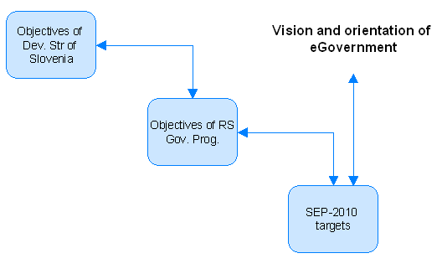
Figure 6: Connection of SEP-2010 targets with other strategy documents
The targets are described in further detail below.

Focus the operations of public administration on user needs
Focus the operations of public administration on user needs via modern communications channels and eGovernment services, whereby all electronic services which they require in their key life situations will be established. They must be easy to use and transparent, with the help of the common entry point, electronic identification mechanisms, electronic payment service and electronic notification.

Increase the quality and efficiency of the functioning of public administration
Increase the quality and efficiency of the functioning of public administration and thereby increase savings. This will be provided through faster carrying out of procedures due to better access to data from key registers and their interconnectedness, the optimisation of processes and information technology, and horizontal connections between information solutions and user training.

Increase user satisfaction
Increase the satisfaction of service users through the provision of simple, fast and inexpensive e-services, and establish it through appropriate measurements.

Reduce administrative burdens
Reduce administrative burdens for the business sector and citizens, such that access to data from key registers will be simple, and data and services will be available in one place following uncomplicated procedures.

Increase the transparency of operations of public administration
Increase the transparency of the operations of public administration from the point of view of citizens as well as public employees. Access to the status of one’s own affairs will be made possible at any time through the eGovernment portal, and a common entry point will be established.

Achieve synergetic effects at all levels of public administration through the use of eGovernment
Synergetic effects must be achieved at all levels of public administration through the use of eGovernment. They will be achieved through the carrying out of key projects of informatisation and optimisation of operations, the results of which will be useful for both the state administration and local self-government.

Include the widest circle of users in the decision-making process
By including the widest circle of users in decision-making processes on important current topics for the state, the mediation of important information, viewpoints and opinions will be made possible in order to create more acceptable Government proposals and policies. These will be based on a multitude of different points of view through the use of e-democracy (e.g. establish e-democracy applications on the eGovernment portal, e-elections, monitoring of legislative changes, e-forums, e-petitions, e-voting, topical discussion websites etc.).

Optimise the consumption of funds in the field of eGovernment
The best possible use of funds for eGovernment will be achieved through joint procurement in the fields of informatics, the optimisation of operations and the creation of generic solutions which can be used repeatedly.

Reduce the burden on human resources in administrative procedures
Reducing the burden on human resources in administrative procedures and focussing on professional tasks will be achieved through the automation and informatisation of procedures and through training.

Maintain the level of development of eGovernment
In order to maintain a level of development of eGovernment comparable with other countries of the EU, it will be necessary to constantly monitor and compare such development in the EU and promote those areas which according to the assessments of the EU and Slovenia will bring the greatest benefits for all involved in eGovernment.

Objective goals of eGovernment
In order to achieve the above-stated targets, which follow from the vision and orientations of eGovernment, numerous measurable objective and project goals will be set, which will be presented in more detail in the eGovernment Action Plan (described in item 10, Implementation of the strategy). At the same time a favourable environment will be created and conditions will be fulfilled which are required for the implementation of eGovernment (presented in item 8, Conditions for directed development of eGovernment to 2010).
The overall picture, or a summary of the target status of eGovernment, can be presented through three periods up to 2010.

In 2006
A more complete package of e-services will be provided for citizens and businesses, and at the same time numerous training and promotional activities will be performed in order to encourage more active use of eGovernment. In the first stage, existing e-services will be upgraded, new e-services will be developed and complete user support will be provided. The services which will be available in 2006 will be easier to access in one place via a common eGovernment Internet portal.
In 2007 and 2008
Major progress will be made towards more efficient internal administration operations with the support of eGovernment. The emphasis will be on upgrading, integration and informatisation of internal administration processes, introducing standardised horizontal and vertical solutions, implementation of standardised information technology platforms, interoperability of eGovernment solutions and services, new operational models, user training and establishing a uniform eGovernment architecture. The revision of business processes, informatisation and the linking of administration databases are especially important to the success of eGovernment. Business processes must be efficient, transparent, interconnected and oriented towards the needs of users of eGovernment. Revised business processes form the basis for achieving the objectives of eGovernment. At the end of the period, eGovernment will be complete and uniform, and user satisfaction will be increased, which will result in the improvement of existing and the introduction of new e-services.
In 2009 and 2010
With the help of eGovernment, all three branches will be better connected. Efforts in this period will be directed towards complete integration of the information and telecommunications infrastructure, revision of business processes at the level of the entire eGovernment and the integration of various e-services into a unified system for complete processing of life events of citizens and businesses. At the end of the period Slovenia will become one of the leading countries in the EU from the perspective of eGovernment and its direct and indirect benefits. Slovenia is among the world’s 10 most developed countries in the field of e-democracy.

Numerous projects and activities will be carried out in order to implement the target status of eGovernment through the given periods, which will be described in more detail in the eGovernment Action Plan. The following are the most significant:
- 2006:
  - Uniform entry point for legal persons, simple electronic services, rationalisation and information support of processes, access to data in subsystems and data exchange, e-signatures, e-serving and providing transparent, affordable and responsive public administration. Interconnections of the state administration for acquiring certificates on the start-up of legal persons, automatic data exchange with legal persons and their subsystems.
- 2007 and 2008:
  - Establishing of central records of social transfers.
  - Linking of social transfer databases and databases which are important for decisions about rights.
  - Information support for decision-making on social transfers. e-decisions, e-resolutions, e-return of service.
  - Single entry point (portal) – one-stop shop for exercising and making decisions on social rights.
  - Linking of the land register, land cadastre and building cadastre (inter-domain data exchange).
  - Establishment of electronic archives (information solutions for archiving web content and key content which arises in e-form as part of the projects for supporting the founding of legal persons).
- 2009 and 2010
  - Exchange of data with EU institutions, which will ensure connections between registers and other official records in the RS, electronic exchange of data among RS public administration institutions and institutions in other EU member states.
  - Integration of public administration processes, information and services between all three branches of government.

Criteria for decision-making on priority eGovernment projects
During the implementation of the strategy, the objectives to 2010 will directly and indirectly generate numerous projects and activities, in which it will be necessary to adhere to the main guideline of focusing on users and their requirements, and the guideline of rationalisation, optimisation and standardisation of operations. Through following the guidelines a connection will be established between the users and the results of eGovernment The figure below shows the constant cycle of adjustments and improvements which are oriented towards increased user satisfaction (the figure shows the example of the adjustment of e-services as one of the most important elements of eGovernment).

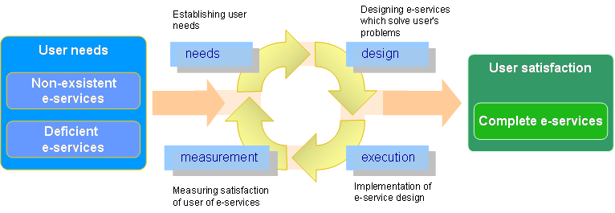
Figure 7: Improving e-services and adaptation to users
Determining the priorities of eGovernment projects will be a process which will include harmonisation with the objectives of SEP-2010, interdepartmental harmonisation and linking, harmonisation with the priority tasks of the EU, verifying the inclusion of proposed projects in strategies and programmes (e.g. Programme of the Government of the RS and departmental authorities), provision of funding, surveying final users, assessment of the completeness of e-services etc.
More concretely, three of the first criteria (the first “filter”) for determining the priority of projects are harmonisation with priority tasks of the Government of the RS (user orientation, more efficient system of public employees and effective management of human resources, more efficient and higher quality operations and openness and transparency of the functioning of public administration), harmonisation with the objectives of the eGovernment strategy SEP-2010 (item 7. Orientations and objectives to 2010) and harmonisation with generally accepted principles of development of eGovernment, whereby the priority e-services are those:
- which users need and use most often
- in which we can expect rationalisation, optimisation and standardisation of operations
- which cover a large part of a given life situation
- in which it is possible to reduce the waiting period for solution of matters and to reduce response times
- in which it is possible to reduce the costs of procedures for the administration and for citizens
- in which it is possible to reduce paper documentation
- in which it is possible to offer new services or increase the quality of existing ones through informatisation
- in which administrative procedures are not the best and are not linked
- which enable the direct co-operation of citizens and civil society in the functioning of public and state administration and in joint decision-making on topics of national importance

Integration and harmonisation of priority projects will be performed in an organised and transparent manner. A central collection and harmonisation point will be established. The further monitoring of the projects and reporting about those which will be included in eGovernment will also be performed in a transparent manner. This will be organised through the eGovernment Action Plan, an information support solution and appropriate organisation of the management of the eGovernment project environment.

Conditions for directed development of eGovernment to 2010

Conditions for development of eGovernment to 2010
In addition to the vision, orientations and goals, in this chapter SEP-2010 lists the main conditions whose fulfilment will enable the directed development of eGovernment. Their fulfilment is of crucial importance for the projects and tasks foreseen in SEP-2010. The development conditions can be expanded into nine areas, which we can call the nine keys to eGovernment: 1. revision of operations, 2. reorganisation, 3. legal and formal bases, 4. management, 5. human resources, 6. training and knowledge, 7. funding, 8. promotion, 9. information solutions. By providing the appropriate conditions in administration in all nine key areas, it will be possible, as shown in the figure below, to satisfy user requirements such that they are satisfied with the services and solutions of eGovernment.
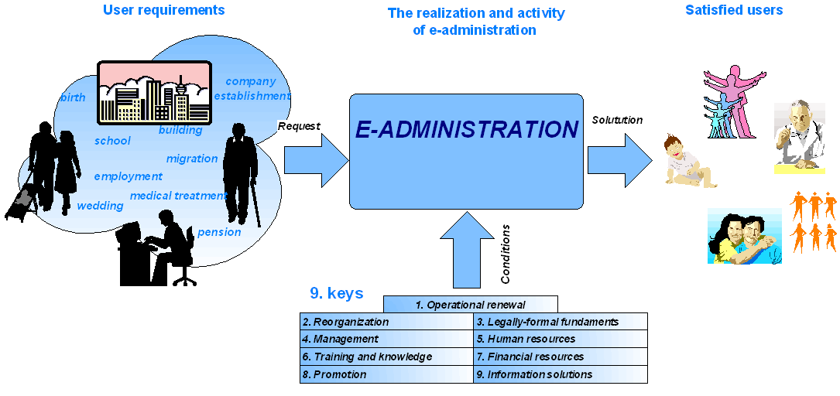
Figure 8: From user requirements to satisfied users via eGovernment
In order to implement the priority solutions and services of eGovernment, it is necessary to provide the appropriate conditions or factors in administration in all nine key areas. The conditions and key tasks for the directed development of eGovernment are presented in detail below.

1. Revision of operations
- Optimization and reengineering of business processes: this is one of the key tasks for the successful implementation of eGovernment and for the best possible results. These will not occur through the introduction of e-services without the optimization and reengineering of processes which can be categorised into a certain area with respect to their content (e.g. finance), into a certain organisation (e.g. a ministry) or simply at the level of individual processes. The optimization and reengineering of business processes is also frequently connected with further reorganisation, human resources, the preparation or adaptation of legal and formal bases, training and funding.
- Upgrading of back-office systems: this is closely connected with the revision of business processes, but at the same time it is necessary to provide the connection of back-office information systems with the entire range of e-services. Within the framework of the revision of back-office information systems it is necessary to strive for their standardisation and the provision of linked information systems for joint functions or processes in administration.
- Horizontal connections: when is about optimization and reengineering business processes attention must be paid to so-called horizontal connections at the level of information systems, e-services, and uniform information architecture and databases, as well as at the organisation level (interdepartmental co-operation in the implementation of eGovernment). The first steps have already been taken and have to be continued (e.g. linking of joint administrative registers and applicative equipment i.e. individual administrative information systems).
- Measuring the effects of e-services and user satisfaction with respect to the constant improvement of eGovernment and the processes which are carried out within it, it will be necessary to introduce regular checking of the effects of e-services and user satisfaction (at least every six months). The findings will serve as the basis for the further development of eGovernment and the further revision of processes.

2. Legal and formal bases
- Provision of legal and formal conditions: the process of the development of eGovernment is, as we have mentioned several times, highly dependent on the legal and formal bases, which are in some cases already adapted to eBusiness and eGovernment, in other cases are limiting and obstruct eBusiness, and in a third group of cases it is only necessary to explain them appropriately and achieve a consensus in order to arrive at a solution. The establishment of some eGovernment solutions requires the fulfilment of legal and formal conditions. In the previous period several such conditions were prepared which furthered eBusiness. The constant appearance of new tasks is also forecast for the future. The legal and formal aspect will have to be included in all eGovernment projects, discrepancies will have to be checked and solutions prepared.

3. Reorganisation
- Competences: in the initial period of the strategy and during its implementation it will be necessary to check the competences, tasks and organisation of the administration institutions and authorities which participate in the eGovernment development process. They must be prepared to perform all tasks which arise from the strategy. Changes will be proposed upon the appearance of any sort of discrepancies.
- New models of operations in the development of eGovernment in future it will be necessary to develop new models of operations between the public and private sectors, which offer services which will improve eGovernment. One of the possibilities is Public Private Partnership (PPP), some e-services are performed by legal persons (intermediaries), which opens up new methods of financing and resource provision. Major opportunities are also indicated for intermediaries in communications of businesses and citizens with administration.
- New organisational forms of informatics: during the period of the new strategy it will be necessary to recheck the suitability of the organisation and functioning of all key institutions in the development of eGovernment. It will be necessary to prepare new forms of organisation in order to achieve the best results in this field, which concern user satisfaction as well as use of resources and funding. Opportunities are indicated for the reorganisation of key authorities responsible for the informatisation of the administration, and the revision of their status, opportunities for the professionalisation of informatics, for privatisation and for new models of co-operation between administration and businesses.

4. Management
- Modern managers in administration during the entire process of the development of eGovernment, a crucial role will be played by managers who adopt decisions, support the entire process and provide conditions in various areas. In eGovernment they have to make decisions which promote accelerated development, monitor its progress and any deviations, monitor measures for the elimination of obstacles, have suitable backgrounds and experience and last but not least have the ability to see the wider picture of eGovernment, which is actually providing the opportunity for modern administration. All levels of management (upper, middle and lower) will have to support and encourage the development of all types of e-services and understand the concept of modern business models.
- The modern manager – eGovernment promoter modern managers are expected to understand the opportunities and benefits of eGovernment, and therefore support the inclusion of projects and employees in its development processes.

5. Human resources
- Human resources: in order to ensure the implementation of the strategy and the optimal flow of projects and tasks, it will be necessary to provide appropriately qualified personnel at management level, as well as at the level of individual professional fields. The provision of professionals is also connected with the ensuring of conditions and environments in which it is possible to train and retain key employees.
- Employee motivation: in future it will be necessary to introduce new methods to attract professionals who will recognise in eGovernment challenges for their professional development and opportunities for increasing the quality of life of users. It will be necessary to appropriately manage innovative ideas, evaluate them immediately and implement them if necessary.

6. Information solutions
- eGovernment using organised approaches, investment studies, project leadership and methodologies: the development of eGovernment must proceed in an organised, harmonised and transparent manner. There are several mechanisms which ensure such organisation, increase the probability of success upon the completion of a project, and enable the continued management of the life cycle of various eGovernment solutions: investment studies, project leadership, project leadership methodologies and development of solutions. These mechanisms are applied depending on the complexity of the field in question.
- Complete e-services and solutions for eGovernment in the initial period it will be necessary to establish possibilities for providing more complete e-services and eGovernment solutions. More complete in the sense that public administration authorities will use uniform standards and recommendations for eGovernment solutions, a uniform eGovernment architecture, uniform infrastructural elements and an interoperability framework. Uniform solutions can be re-applied in the implementation of numerous e-services. The actual implementation of these services will be possible in the infrastructure of the public administration or through providers of ICT services and solutions.
- Information system for receiving applications, serving and notification pursuant to the article of the Act amending the General Administrative Procedure Act (ZUP-C), the further expansion and development of a uniform information system must be provided which enables the receiving of applications, serving and electronic notification of clients about the progress and conclusion of procedures.
- Creation of a list of registers and records: this is at the same time a task involving the definition of the basic records of the public administration. Connections between them must be defined in order to provide further informatisation, increased transparency and accessibility of data. The definition of organisational, semantic and technical standards for linking records will also enable normative organisation. A project group has been formed for creating links between official records, which will discuss the problems and present solutions. The result of the work of this group will be a metaregister of records in public administration.
- Informatisation and linking of databases: by 2010 it will be necessary to informatise the majority of databases (registers, records etc.) in public administration, establish links between them and open the databases to users outside and within public administration. In parallel with technical and information solutions, it will also be necessary to provide for normative solutions, especially taking into account the principle that links are established between databases which in their opinion and in accordance with the principle of proportionality are suitable for linking.
- Central information and telecommunications infrastructure (strategic elements of eGovernment) in future it will be necessary to continue efforts and investments in creating a central information and telecommunications infrastructure for eGovernment solutions which will be available to public administration. In this way the costs of this infrastructure will be lower, the quality of the services increased, and the solutions standardised. A more detailed description can be found under item 9, Central information and telecommunications infrastructure of eGovernment
- The establishment of a system of monitoring and management of e-services will be necessary in order to provide fast, quality and safe e-services to all eGovernment users.
- Development of e-services: will have to be continued in individual fields of administration. For already developed e-services it will be necessary in a short period of time to obtain as many users as possible, new users will have to be guided mainly to those areas and life events which are most common, and which would bring the greatest benefits to eGovernment users and the greatest savings in administration (high impact services).
- Pan-European eGovernment services: creative and active participation in the forming of pan-European eGovernment services, identification of these services, exchange of best practices and co-operation in the designing of the interoperability framework.
- Central payments system it will be necessary to establish a system which will make possible various types of payment for services rendered in administration.
- Identification and authentication: it will be necessary to establish a system (module) which will enable simple and user-friendly identification (electronic identity) and authentication for all eGovernment services.
- User-friendliness of e-services: one of the basic priority tasks in the implementation of eGovernment in the next few years is to increase the simplicity and utility of e-services for citizens, businesses and public employees. All three of these groups of users have certain common requirements which must serve as the starting points for the planning and implementation of e-services. The services must be accessible through the eGovernment portal and listed in appropriate categories which are understandable to users and located in a visible place. They will have to follow certain logic and design regulations which will ensure the homogeneity of comparable e-services. If any problems appear, users must have electronic and if necessary personal assistance available at all times.
- Creation of a list and categorisation of life events and e-services which users expect and use most frequently.
- Complete e-services: the performance of complete services via the Internet must be provided, so that the sending of paper documents or meeting face to face with public employees will not be necessary. In order to provide complete coverage of various fields of public services, it will be necessary to increase their selection, which is still insufficient, especially for public employees. Despite this, classical channels for provision of services must remain available.
- Uniform eGovernment architecture: for the further uniform and rational development of eGovernment it will be necessary to establish a uniform architecture for its information system, determine the common elements of e-services, and uniform standards and uniform recommendations which all public administration authorities will be able to use in the development of e-services. It will be important to provide accessibility, transparency and internal promotion of the uniform architecture.
- Standards and recommendations: development projects for e-services and other eGovernment solutions will have to take into account uniform interoperable standards and recommendations for uniform architecture in this field which will be harmonised with EU standards and recommendations (e.g. the IDAbc programme). To this end it will be necessary to continue the continuous task of preparing standards and recommendations and to insert them in plans and development of e-services. This task includes the preparation of uniform standards and recommendations for the procurement of information technology as well as giving opinions in procurement processes in accordance with them.
- Interoperability framework: linking of all elements (standards and recommendations, uniform architecture, open standards and solutions, guidelines) in a national interoperability framework for eGovernment services and solutions which will provide organisational, semantic and technical interoperability and at the same time creative co-operation in the preparation of an interoperability framework for pan-European services.
- Modern technologies: it will be necessary to continue monitoring new information technologies and regularly preparing uniform technological requirements and bases for their use in eGovernment projects.
- Open Standards and Open Source: it will be necessary to draw up recommendations for the use of modern open standards and open codes for the development of eGovernment and to continue to actively monitor solutions in this field. In this regard, numerous challenges are foreseen in the upcoming period of the strategy.
- eGovernment solutions in EU countries: it will be necessary to provide regular monitoring of eGovernment projects in EU countries and to become actively involved in their implementation. In connection with this it will be necessary to seek the best practice and verify possibilities for their implementation in Slovenia.
- Continuous development of the information society: it will be necessary to continue tasks and initiatives for the development of the information society in Slovenia and for the reduction of digital divide. Among other things, it will be necessary to provide access to eGovernment via fast communications connections, establish new clear Internet access points, promote the development and use of third-generation mobile communications, provide new channels and devices for access to the Internet and e-services and also to provide access to it in the majority of Slovene households. In the previous period this problem was discussed in the Strategy of the RS in the Information Society, which has to be continued in order to support and initiate appropriate activities directed towards the further development of the information society.
- Regular monitoring of implementation of eGovernment: it will be necessary to provide organisation, procedures and an information system for continuous monitoring of the implementation of eGovernment.
- Introduction and management of tools for e-democracy: e-consultancy, topical discussion websites, e-forums, chat rooms, e-voting, e-petitions etc.

7. Training and knowledge
- Training of public employees in order to increase efficiency and innovativeness: will create the opportunity to increase the efficiency of business processes. However, new knowledge alone is not sufficient – the organisational culture of the public administration must be gradually adjusted in order to encourage employees to use their knowledge and to acquire new knowledge at their own initiative. This will increase the satisfaction of public employees as well as users of e-services.
- Participation of public employees in international eGovernment projects: in order to exchange good practice and gain experience and knowledge, it will be necessary to increase the active inclusion of public employees in international eGovernment projects.
- Training of users of e-services: it will be necessary to prepare, present and carry out new training programmes for users of e-services. Through active training can be expected to lead to the growth of the use of these services. The tasks include: organisation of courses or public presentations of the use of e-services at least once a year for each e-service to 2010 for citizens and businesses, organisation of training in the use of e-services for administration employees at least once a year.
- eGovernment Contact Centre: it will be necessary to provide help to users in advance and upgrade it in order to provide constant (24/7) and complete service. It will have to be established for those who have Internet skills and also for those who do not. Help will have to be available for technical (e.g. in connection with e-services, use of digital certificates) and content questions, and will be accessible via uniform entry points (e.g. telephone number, email). At the contact centre it will be necessary to achieve an appropriate level of knowledge and a flexible organisation which will be able to increase its capacities when under heavy loads.
- Transfer of knowledge from development organisations and faculties into eGovernment practice: numerous theoretical bases, research, prototypes and innovative solutions developed in various development-oriented organisations and faculties will also be applicable in eGovernment. In Slovenia there are innovative solutions, domestic knowledge and experiences which can be transferred to eGovernment.
- Transfer of knowledge and experience from administration to business: there are many areas of administration, including e.g. informatics, which harbour a wealth of knowledge and experience. Through correct and transparent partnership associations between administration and business, this knowledge and experience could be expanded to the business sector, and then additionally expanded, since there are possibilities for innovative feedback solutions for eGovernment.
- Transfer of practice and solutions to other countries: Slovenia is known as an advanced country with regard to eGovernment, and it can transfer its knowledge and practice to other EU member states or candidate countries. To this end it will be necessary to establish appropriate connections, become involved in EU projects and regularly monitor opportunities.

8. Funding
- Provision of funding: this is one of the fundamental challenges for the implementation of the strategy to 2010. Various mechanisms for providing funding are currently very well-established and tested, but according to professional assessments they will not be able to withstand further burdening. Funding for informatisation is planned and received from the state budget, and the majority is allocated for eGovernment development projects, purchasing of equipment, and external contractors and their services. The inclusion of external contractors in projects and procurement is conducted through public calls for tenders, and contracts are signed with selected contractors, which represent the basic mechanism for managing them. In order to provide more stable provision of funding for eGovernment, it will be necessary to develop and use new approaches and models. Some of these are presented below.
- Public Private Partnership (PPP): based on long-term co-operation, in this case on information projects or services which are primarily carried out by the public administration. The purpose of co-operation is more efficient and successful functioning of the administration and businesses, which requires a new model of operation based on transparent and formally correct partnership.
- EU funding (structural funds): increased opportunities will be created for public and private organisations to obtain funding for various ICT projects. Funding or co-financing is available within the following EU programmes: eTen, eContent, Seventh Framework Programme (IST), IDAbc, Safer Internet and Structural Funds. The joining together of several partners and appearing with combined forces is recommended. In order to receive funding from various EU programmes it will be necessary to be appropriately organised and amalgamated. Inappropriate combinations of partners or similar combinations of partners for the same purposes can lead to partial information solutions, overlapping solutions and non-optimal use of funds (e.g. carrying out two similar projects which receive funding from different programmes is not reasonable – combining would be more efficient). To this end it will be necessary to establish a system of efficient notification of all interested parties and encouraging joint projects for uniform solutions, which have the possibility of success also outside Slovenian borders.
- E-services create savings: the purpose of e-services is among other things to lower costs. The implementation of e-services is usually fundamentally less expensive than implementation using classical communications channels (e.g. service windows at administrative units), which means a savings and at the same time a reduction of the burden on employees, and can be directed into higher impact services for users. By establishing mechanisms for determining savings they will be clearly visible and can be a source of funding for the development of new and improved e-services. In order to obtain a complete picture of savings it is also necessary to take into account savings from e-business within the administration (G2G), which can be in certain cases even higher than those obtained through the performance of e-services for final users.
- Additional services: the public sector can offer citizens and businesses additional high impact services (the PPP model is also applicable here) which citizens and businesses are prepared to pay for. Funds obtained in this manner can be an additional source for the further development of eGovernment and consequent increased satisfaction of citizens.

9. Promotion
- Promotion of eGovernment: providers must provide appropriate promotion of e-services and the technologies on which they are based (e.g. digital certificates, which are the initial condition for the use of many e-services). The advantages of e-services must be presented to users in a pleasant and unambiguous manner.
- Encouraging co-operation: it will be necessary to introduce more efficient mechanisms for encouraging co-operation among public administration authorities in the development of eGovernment. At the same time the consultancy and mentorship roles of the MPA must be strengthened, as well as the internal introduction of eGovernment.
- Monitoring and notification: in the initial period it will be necessary to additionally strengthen mechanisms for monitoring implementation and providing information to participants on this basis.

The fulfilment of these conditions, and especially good co-operation of suitable professionals and a sufficient amount of funding in order to implement the strategy, will be the guideline for the achievement of the objectives of eGovernment. Organisational and informational changes at the level of the entire public administration are exceptionally complex and require an appropriate amount of resources and funding. The organisation therefore has to be sufficiently dynamic to respond to the changing needs of administration and users, selectively introduce new information technologies and take appropriate measures in response to economic and political changes.

Central information and telecommunications infrastructure of eGovernment
The provision of a central information and telecommunications infrastructure for eGovernment or infrastructure elements of eGovernment (abbr. CITI) is one of the conditions (item 8 above) for the directed development of eGovernment to 2010. The use of this infrastructure will make it possible to achieve lower costs of development and operation of eGovernment, increased quality and uniformity of solutions and interoperability.
With regard to CITI it will be necessary to determine the rules or conditions of use for the entire public administration, and at the same time to clearly define the competences and sources of funding for its establishment and functioning. The ministries competent for the management of individual parts of the central information and telecommunications infrastructure (for the most part the Ministry of Public Administration) will continuously verify and harmonise the rules of use, sources of financing and business models for its functioning in order to implement eGovernment.
The following elements are understood to fall under CITI:
- The HKOM national telecommunications network. HKOM is managed by the MPA, and this is also foreseen for the future. In the period of SEP-2010 the network will be modernised and upgraded to higher transfer rates. The manager of the HKOM network will with the support of the Ministry of the Economy undertake to use the available telecommunications infrastructure on the public railway network and the public motorway infrastructure to the greatest possible extent when upgrading the HKOM network. It will be used in the spirit of good management practice and exclusively for the needs of the joint communications network of the state authorities. At the same time the emphasis will be on the implementation of secure networks of various levels and purposes (e.g. Internal, Confidential, Secret or data exchange with the EU, NATO etc.).
- Central data centre. The central data centre is managed by the MPA and will be also in future. In the period of SEP-2010 it will be necessary to provide sufficient capacities for the data centre and to carry out tasks for the uninterrupted operation or functioning of eGovernment.
- Key administration registers. These include the Central Population Register (CRP), the Business Register (PRS) and the Register of Spatial Units (RPE), and are part of the central information and telecommunications infrastructure for eGovernment and as such form the basis for the establishment and functioning of key e-services. Keeping of the registers is divided among the competent authorities. In future it will be necessary to provide a review from a single place of access rights (central security scheme, uniform identification) and manners of use of these registers, and to make them available and interoperable (interoperability framework).
- Central spatial infrastructure. This serves as the basis for the implementation of complex spatially related e-services. One part of it are spatial databases (e.g. RPE, Land Cadastre, Building Cadastre, other records of the Surveying and Mapping Authority, Ministry of the Environment and Spatial Planning and other competent authorities). In future it will be necessary to provide increased connection and semantic interoperability between spatial databases.
- Certification agencies SIGEN-CA and SIGOV-CA. Their tasks are carried out within the framework of the MPA, which is also foreseen for the future.
- Agency for Time Stamping. The tasks of this agency are carried out within the framework of the MPA, which is also foreseen for the future.
- eGovernment Contact Centre. The beginnings of the contact centre or contact centres for certain fields already exist. It will be necessary to provide a common entry point by 2010, and in the background to harmonise and link all levels of user assistance.
- Common eGovernment portal: The common eGovernment portal already exists and is being filled with new content and e-services. In future all contents will be updated, and at the same time it will be necessary to provide for uniform application to and for all e-services, for the personalisation and adaptation of the portal for people with limited possibilities and the elderly, taking into account the current guidelines for e-accessibility (Web Accessibility Guidelines) as determined by W3C.
- Common information solutions for the public administration (e.g. email, Internet, office work, central system for receiving applications, serving and notification, central information system for procurement etc.). Various common information solutions already exist. In the coming period others will be clearly recognised and projects will be carried out to improve, revise and link them.
- Common modules and elements of public administration e-services (e.g. central modules for payment, numbering, register interfaces). These are of key importance for faster, cheaper and simpler creation of e-services. Some of these already exist and are being used. In future it will be necessary to determine the conditions for their use in a broader sense, guidelines for further development, and to increase their accessibility.
- CITI security elements. Within state authorities and outside of them, in communications with clients, it will be necessary to provide for the security of data and transactions. This will be ensured through appropriate security mechanisms (use of safe networks, use of digital certificates, digital signatures etc.), the drawing up of security policies, consistent implementation of security policies and taking into account legislation in this field (e.g. protection of personal data, information of public character). Another component part of CITI security elements are recommendations for the drawing up of an information security policy, which will be amended during the period of SEP-2010 and taken into further consideration in the drawing up of security policies.
- Uniform eGovernment architecture (including a metaregister) and interoperability framework with pertaining open standards. Uniform architecture and an interoperability framework are two essential conditions for the provision of uniform and interoperable eGovernment solutions. The beginnings of these mechanisms already exist, and efforts towards their completion will be made in future.
- Methodologies for the development of information solutions, eGovernment project management and quality assurance. Methodologies for all three of the fields concerned already exist, but are not yet completely useable, since several years have passed since they were last revised. It will be necessary to upgrade them and adapt them to the concrete requirements of eGovernment.
- Programme and project office of the Ministry of Public Administration. This office operates within the framework of the MPA and provides central organisational and technical support to eGovernment projects. Its role is clearly defined - it is the operative body for providing support to the implementation of eGovernment.

Implementation of the eGovernment strategy

Process of implementing the strategy (operationalisation)
The implementation of the strategy will have to occur in an organised environment in which the status of the projects, e-services and progress is transparently shown. The environment which was established during the implementation of SEP-2004 proved to be efficient and with certain organisational and procedural adjustments will be capable of managing the eGovernment strategy for the upcoming period.
One of the most important mechanisms in the organised environment for implementing the strategy is the Action Plan. Its primary intent is that of an implementation strategy for eGovernment, since it presents in detail the objective goals, projects and eGovernment e-services which arise from the strategy, and at the same time gives an overview of the current status of the projects and information about the progress of eGovernment in Slovenia. The Action Plan will also in future be one of the most important mechanisms for providing transparency and traceability of the implementation of the SEP-2010 strategy.
The figure below shows the interconnectedness of the objective goals in the eGovernment Action Plan and its pertaining projects with the targets of the strategy and other strategy documents and programmes. The carrying out of eGovernment projects will directly and indirectly contribute to the fulfilment of the objectives of the Programme of the Government of the RS and the Development Strategy of Slovenia.

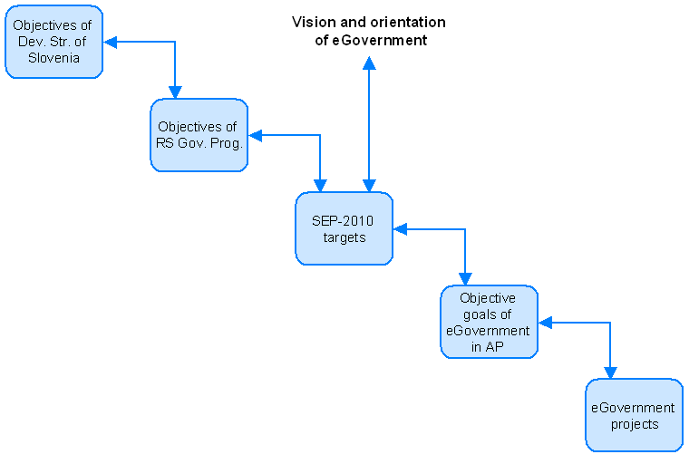
Figure 9: Connection of SEP-2010 targets with eGovernment projects
The purpose of the Action Plan is, in addition to the already known and constant objectives (to provide conditions for the accelerated development of e-business in administration, continuous elimination of obstacles which arise in the development of new e-services, provide to make it possible for the Co-ordinating Body for Better Public Administration to constantly monitor achievements on the basis of European and global comparable indicators and take appropriate actions as needed), to make an assessment of the progress from the first adopted action plan and to support the authorities which are lagging behind in the development of e-services or are carrying out less intensive activities.
A further purpose of the Action Plan is to support the development of e-services which are based on joint EU initiatives and e-services for the internal operations of the administration (internal processes for resolving administrative matters), which in addition to the more efficient development and functioning of these services will also positively affect the speed and efficiency of the performance of services along classical communication channels.
Along with monitoring the implementation of eGovernment it will be necessary to monitor the achieving of the AP objectives, which arise from the strategic objectives of the ministry and the directing and area-centred objectives of eGovernment.

Competences and responsibilities for implementing SEP-2010 and reporting
The agreed organisation with respect to eGovernment projects is the basis for further work in this area, which will follow the fulfilment of the Work Programme and objectives of the Government of the RS and the achieving of SEP-2010. In accordance with the organisational structure and defined competences, responsibilities and duties, the highest decision-making authority for eGovernment projects is the Co-ordinating Body for Better Public Administration.

In accordance with the mandate, the person competent and responsible for management of this area is the head of the working group for eGovernment project co-ordination (hereinafter: eGovernment Manager).
For harmonisation of the management of this area a working group for eGovernment project co-ordination (hereinafter: eGovernment working group) has been established, which is made up of members appointed from ministries, their component authorities and government offices, which are in charge of e-services and/or e-services infrastructure in the eGovernment Action Plan (hereinafter: AP).

Expert project group for management of the AP (hereinafter: AP expert project group) is responsible for the drawing up of the eGovernment Action Plan document.

The Project Council is made up of a chairman and members of the Project Council. The authority which is in charge of the project shall appoint the Chairman of the Project Council to adopt decisions pursuant to these instructions. The extent of his/her competences, responsibilities and duties are in accordance with the provisions of the MVPDU-IT.

The remaining members of the Project Council shall be appointed in accordance with the needs of the authority which is in charge of the project and other authorities which are participating in the project. The extent of their competences, responsibilities and duties are in accordance with the provisions of the MVPDU-IT.

The authority which is in charge of the project shall appoint the project leader for operative management. The Project Council must approve the appointments. The duties of the project leader are in accordance with the MVPDU-IT and are determined in individual founding documents of the projects. The members of the project group are determined by the authority which is in charge of the project internally.

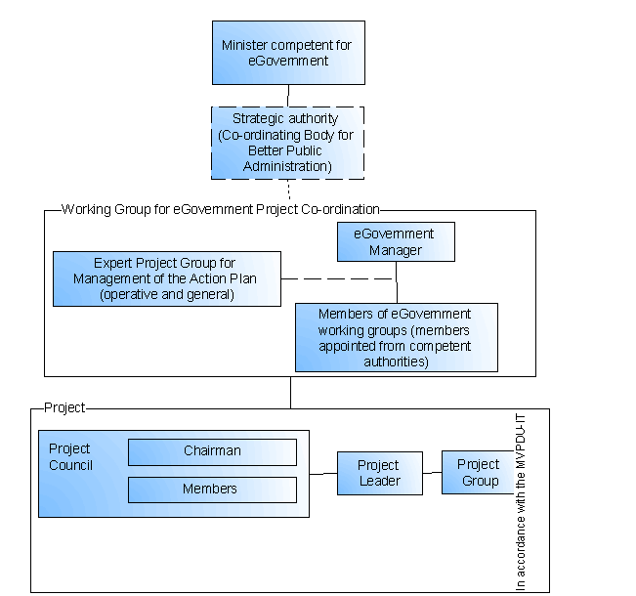
Figure 10: Proposed organisational structure of project leadership in the field of eGovernment

Monitoring the implementation of the strategy
After the adoption of the SEP-2004 transitional eGovernment strategy in 2001, or more precisely upon the approval of the eGovernment Action Plan which arises from SEP-2004, a system was established for monitoring the implementation of the strategy and the Action Plan. During the period of the SEP-2004 strategy this system was developed into a final form, which includes mechanisms for monitoring, reporting and notification, a methodology for taking measurements, and an information system which supports the operations of the entire system.
During the period of the new strategy the existing system will be changed and its implementation amended and improved with respect to organisational changes in administration and the new objectives of eGovernment. The upgrade will include reorganisation, changes to procedures, multi-parameter monitoring of the strategy and Action Plan, the introduction of new levels of monitoring, methodological adjustments, the preparation of measures for deviations from plans and the adaptation of the information system. The starting points for further development of the system for monitoring the implementation of SEP-2010 are given below.

Reporting on the progress of eGovernment
Members of the working group for project co-ordination of eGovernment (see Figure 10), which is composed of members appointed from ministries, their component authorities and government offices, report on the progress of eGovernment projects at regular meetings of the working group for project co-ordination of eGovernment and in periodic reports.
The head of the working group for project co-ordination of eGovernment reports on the status of the progress of eGovernment to the Co-ordinating Body for Better Public Administration.
The strategic Co-ordinating Body for Better Public Administration discusses the reports on the progress of eGovernment and adopts decisions. When decisions are required at a higher level (e.g. complex interdepartmental projects, problems with projects), the minister responsible for eGovernment, who heads the co-ordinating body, reports on the status of the progress of eGovernment to the Government of the RS and proposes measures.

Methodology for determining the degree of fulfilment of the eGovernment strategy
Determining the degree of fulfilment of the eGovernment strategy will occur on several levels, which will ensure a correct picture of the situation and activity towards the achievement of the objectives. The degree of fulfilment of the strategy will be determined through measurements, indicators and comparisons, which will be combined in periodic reports.
The first level of determining the degree of fulfilment of the eGovernment strategy will include checking the achievement of the strategic objectives. Appropriate indicators and criteria will be established for this purpose.
The second level will include checking the fulfilment of the eGovernment Action Plan, which is a logical consequence of the eGovernment strategy. This plan follows the strategy and presents and breaks down the eGovernment projects in more detail, to the level of actual projects, e-services and permanent technological tasks. The fulfilment of the Action Plan will be checked in an already existing manner (e.g. monitoring projects according to various types of status, number of e-services provided).
The third level of determining the degree of fulfilment of the eGovernment strategy includes periodic monitoring of indicators of the level of development of eGovernment according to EU methodology and comparisons with other EU countries. In some parts, the eGovernment strategy follows EU guidelines and recommendations, which see key priority tasks in administration operations for citizens and businesses.
The fourth level of determining the degree of fulfilment of the eGovernment strategy, and not the least important, is the checking of user satisfaction (citizens, businesses, public employees) and their further needs which can be fulfilled by eGovernment.

Management procedures in the field of eGovernment projects
In connection with the initial tasks for the further development of eGovernment, two documents have been drawn up at the MPA. “Operative procedures and instructions for project management in the co-ordination of eGovernment”, which describes in detail the organisation, responsible parties, duties and procedures for managing eGovernment projects, and “Methodological basis and instructions for measuring the success of eGovernment”.
The documents precisely define the following procedures:
- determination of eGovernment projects
- preparation and establishment of projects
- reporting and supervision in the framework of co-ordination of eGovernment projects
- conclusion of projects
- meetings of the Project Council
- meetings of the working group for eGovernment project co-ordination
- procedures for measuring success in the field of eGovernment projects
- procedure of drawing up the action plan

The documents also determine in detail the documentation which must be produced in the implementation of these procedures and the information support used for this.

Action
Regular checking of the fulfilment of the eGovernment strategy and reports and notifications prepared on that basis form the basis for appropriate actions to be taken upon discrepancies from the established guidelines or upon the appearance of new opportunities. Every opportunity to improve eGovernment must be taken advantage of.
In the upcoming period of the strategy, appropriate mechanisms will be established for taking action upon discrepancies from the established guidelines, and eGovernment development frameworks and processes will be agreed upon. The measures will be intended mainly to support the elimination of problematic situations which were identified in the previous strategy period.
- Promotion of the co-operation of all participants in eGovernment development processes, reporting and notification (e.g. progress reports must be written every month by all participating competent authorities responsible for e-services).
- Promotion of progress in less intensive eGovernment projects (e.g. the status of projects which have not borne results for some time and are not progressing has to be rechecked and more active implementation has to be provided for, if appropriate, or alternatives for escaping the situation must be proposed).
- Promotion of progress in certain eGovernment development areas (e.g. eGovernment areas which are the subject of assessment according to EU methodology and do not achieve at least an average level of development according to EU criteria will require the adopting of measures to induce faster progress).
- Promotion of co-operation between individual competent authorities (e.g. if a competent authority requires the co-operation of another competent authority at the beginning or end of an eGovernment project, such co-operation must be established during the preparation of the project).
- Promotion of the elimination of legal/formal and organisational obstacles (e.g. during the preparation of projects all possible legal/formal and organisational obstacles have to be defined and their elimination must be initiated at the very beginning).
- Promotion of faster introduction of eGovernment solutions into actual use (e.g. some projects are completed but their application is not possible owing to various obstacles. Obstacles must be foreseen at the beginning of or during the project, and eliminated before its completion).

The competent authority for taking action is the Government of the RS, which issues appropriate resolutions and measures on the initiative and expert opinion of the strategic authority at the MPA and the minister responsible for eGovernment.

Sources
[1] Work Programme of the Government of the RS 2005
http://www.vlada.si/index.php?vie=cnt&gr1=dloVld&gr2=prgDla; acquired January 2006.

[2] Work Programme of the Ministry of Public Administration of the RS for 2005; http://www.mju.gov.si/index.php?id=30;
http://www.mju.gov.si/fileadmin/mju.gov.si/pageuploads/mju_dokumenti/doc/Program_dela_MJU_za_Vlado_RS.doc; acquired January 2006.

[3] Work Programme of the Ministry of Public Administration of the RS for 2006;
http://www.mju.gov.si/index.php?id=30; acquired January 2006.

[4] Development Strategy of Slovenia;
http://www.sigov.si/zmar/projekti/srs/StrategijarazvojaSlovenije.pdf 6 ; acquired January 2006;
http://www.sigov.si/zmar/projekti/srs/srs.php ; acquired January 2006;

[5] Reform Programme for Achieving the Lisbon Strategy Goals in Slovenia;
http://www.sigov.si/zmar/projekti/ostalo/lizbonska-strategija/pr-lizbona.pdf; acquired January 2006;

[6] Framework of Social and Economic Reforms for Increasing the Welfare in Slovenia; http://www.vlada.si/index.php?vie=cnt&gr1=dloVld&gr2=vlaPro; acquired January 2006;
http://www.vlada.si//util/bin.php?id=2005122710110054; acquired January 2006.

[7] Ministerial Declaration and guidelines from the ministerial conference “Transforming Public Services, 24 November 2005, Manchester, UK”;
http://www.egov2005conference.gov.uk/programme/index.asp; acquired January 2006.
http://www.egov2005conference.gov.uk/documents/proceedings/pdf/051124declaration.pdf; acquired January 2006.
http://europa.eu.int/information_society/activities/egovernment_research/minconf2005/index_en.htm; acquired January 2006.

[8] Guidelines from the ministerial conference Signposts towards eGovernment, Manchester, 24 November 2005;
http://europa.eu.int/information_society/activities/egovernment_research/doc/minconf2005/signposts2005.pdf; acquired January 2006.

[9] i2010 A European Information Society for Growth and Employment; http://europa.eu.int/information_society/eeurope/i2010/i2010/index_en.htm; acquired January 2006.

[10] IDAbc – Interoperable Delivery of European eGovernment Services to Public Administrations, Businesses and Citizens; http://europa.eu.int/idabc/; acquired January 2006.

[11] eGovernment Beyond 2005; http://europa.eu.int/idabc/servlets/Doc?id=18465; acquired January 2006; http://europa.eu.int/idabc/en/document/3594/5671; acquired January 2006.

[13] eGovernment in the EU in the next decade;
http://europa.eu.int/idabc/servlets/Doc?id=19131; acquired January 2006;
http://europa.eu.int/idabc/en/document/3816/5666; acquired January 2006;

[14] eGovernment Studies 2005 – Helping to Light the Way for eGovernment in Europe towards 2010;
http://europa.eu.int/information_society/activities/egovernment_research/doc/i2010_studies.pdf; acquired January 2006.

[15] Strategy of Slovenia in the Information Society,
http://mid.gov.si/mid/mid.nsf/V/KE332AF03299A027FC1256CCC0042109C/$file/Strategija_RSvID_(2003-02-13).pdf; acquired January 2006.

[16] National Development Programme of the Republic of Slovenia 2001–2006; http://www.pososki-rc.si/sites/www/files/1-dpr-pov.pdf; acquired January 2006.

[17] eBusiness Strategy for Local Communities; http://mid.gov.si/mid/mid.nsf/V/K272A63676CBC6B0CC1256CDF00308AD2/$file/LS_Strategija_e-poslovanja_lokalnih_skupnosti.pdf; acquired January 2006.

[18] Strategy for the Functioning and Development of Administration in the Republic of Slovenia on the Internet;
http://mid.gov.si/mid/mid.nsf/V/K6C08D4EE25C03327C1256F0300203BB9/$file/Strategija_spletnega_nastopa_koncna_20040902.pdf; acquired January 2006.

[19] e-Europe Action Plan 2005;
http://europa.eu.int/information_society/eeurope/2005/all_about/action_plan/index_en.htm; acquired January 2006.

[20] eBusiness Strategy for Public Administration in the RS for the period 2001 to 2004 (SEP-2004); http://e-uprava.gov.si/e-uprava/portalStran.euprava?pageid=48; acquired January 2006; http://e-uprava.gov.si/eud/e-uprava/SEP-dv.pdf; acquired January 2006.

[21] eGovernment Action Plan to 2004;
http://e-uprava.gov.si/e-uprava/portalStran.euprava?pageid=48; acquired January 2006;
http://e-uprava.gov.si/eud/e-uprava/akcijski_nacrt_1.4.pdf; acquired January 2006;

[22] Statistical Information – Information Society, January 2006, Statistical Office of the Republic of Slovenia; http://www.stat.si/tema_ekonomsko_infdruzba.asp acquired April 2006.

[23] Mid-term programme 2006-2007 for Cooperation between the directors general
Responsible for public administration in the EU member states http://www.eupan.org/cms/repository/document/12_MidTerm%20Programme%202006_2007.pdf, acquired March 2006.

Only countries for which data were available were taken into account, source: http://www.stat.si/tema_ekonomsko_infdruzba.asp, April 2006.

